As-Built Documentation

  - Project Name: MS Fabric Data Consolidation & Enhancement Project
  - Project Code:
  - Document status: Final

Created on 3 Dec 2024
Updated on 26 May 2025

Our Partners and Certifications


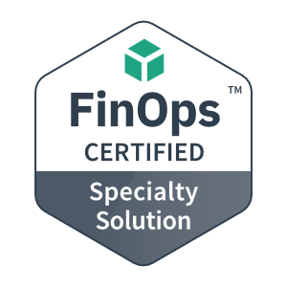



Revision History
Version | Author | Issue Date | Changes
Initial | Anoop Ananth | 3/12/2024 | Initial document
Ver. 0.1 | AJ Rupasinghege | 16/12/2024 | Initial review
Ver 1.0 | Anoop Ananth | 5/05/2025 | Initial version
Ver 1.1 | Anoop Ananth | 26/05/2025 | Updated version
Ver 1.2 | Jack Foster | 15/04/2026 | Update to include Planning API ingestion.
Ver 1.3 | Jack Foster | 03/04/2026 | Update to BAMC and BOAMS ingestion
Ver 1.4 | Jack Foster | 07/09/2026 | Rewrote Section 3.7 Alerting and Notifications for the current Activator-based alerting, added Section 3.8 Pipeline Monitoring and Reporting, and updated Section 4.8 Observability and Monitoring.

Distribution List
Name | Title | Business Unit | Responsibility

References

Document Name | Network Location or Documentation Link

Table of Contents
Revision History 3
Distribution List 3
References 3
Table of Contents 4
1 Introduction 6
1.1 Purpose 6
1.2 Target Audience 6
2 Solution Overview 6
2.1 High-level Architecture 6
3 Data platform 7
3.1 Fabric Capacity specification 7
3.2 Data Ingestion Framework 8
3.3 Data Ingestion Patterns 19
3.4 Metadata Structure 27
3.5 Data Persistence/Medallion Architecture 28
3.6 Data Transformation 35
3.7 Alerting and Notifications 39
3.8 Azure Repos 41
4 Platform Operational Pillars 42
4.1 Data Governance 42
4.2 Data Quality 43
4.3 Data Security 44
4.4 EntraID (AAD) Security Groups for Fabric access 45
4.5 Data Access / Semantic Layer 45
4.6 Scalability and Performance 46
4.7 Data Consistency and Validation 48
4.8 Observability and Monitoring 49
4.9 Cost Management 50
4.10 Interoperability and Integration 52
5 Use-cases 53
5.1 BioNet API Ingestion 53
5.2 e-Planning API Ingestion 55
5.3 Salesforce API Ingestion 57
5.4 GOULBDB On-Premises SQL Ingestion 59
5.5 SharePoint Ingestion 61
5.6 Planning API Ingestion 63
5.7 Pipeline Schedules 67
6 Continuous Integration & Deployment (CI/CD) 68
6.1 Introduction 68
6.2 Continuous Integration (CI) Stage 68
6.3 Best Recommendation for CI 69
6.4 Continuous Deployment (CD) 69
6.5 Comparison of Deployment Methods 72
6.6 Fabric Development Rules 73
7 Power BI Reports Documentation 74
7.1 Current State 74
7.2 Semantic Models and Dataflows 74
7.3 Semantic Model Ownership 76
7.4 Fabric Migration – Completed Transition Summary 76
7.5 Fabric Reports links 78
8 Standard Operating Procedures 80
8.1 Data Ingestion and BAU Activities 80
8.2 Administration and Management 86
9 Appendix 88
9.1 Decision Register 88
9.2 Supporting Documents and Artifacts 88

Introduction

Purpose
The purpose of this document is to present a comprehensive overview of the as-built solution for the DCCEEW Microsoft Fabric Data Consolidation Enhancement Project.
The As-built documentation aims to provide stakeholders, decision-makers, and project participants with a clear understanding of the solution implementation, including:
- Solution overview – high-level and detailed architecture
- Solution components – the Microsoft Fabric components used within the architecture to achieve project objectives

Target Audience
This As-Built documentation is a technical record of the platform's construction, development, solution design, and architecture. Created by software/data engineers, programmers, report developers, and project managers, it is intended for stakeholders at DCCEEW, including project managers, software testers, software engineers, technical support and quality assurance teams.
Project managers will use this document to verify that the platform aligns with the original design specifications and to identify any discrepancies. Software testers will refer to it to ensure it meets functionality and performance requirements. Software engineers and quality assurance teams will utilise the document to evaluate the software's quality and guide future development decisions.
The As-Built document offers a comprehensive and accurate account of the project's development. It can be shared internally within DCCEEW and used to demonstrate that the platform fulfils its requirements and operates effectively for its users.

Solution Overview

High-level Architecture
To view the high level architecture for the solution, please see document DPHI Solution Design - Fabric Data Platform-v1.00.

Data platform

Fabric Capacity specification
In Microsoft Fabric, the Fabric capacity SKU governs the compute and storage resources available to workspaces and items such as dataflows, notebooks, and Power BI reports.
A single F4 Capacity (bosdatanonprod) was provisioned to support the platform across the Non-Prod and Prod environments.
Environment | Compute based on Capacity SKU | Purpose
Non-Prod | F4 | Conduct transformations within Spark notebooks for the Development (Non-Prod) environment
Prod | F4 | Conduct transformations within Spark notebooks for the Production environment

Note: We recommend separating the production capacity from non-production to ensure the production activities are not impacted.

Data Ingestion Framework

Ingestion Pipelines
Ingestion pipelines serve as the entry point to the data platform, leveraging a framework that utilises both native and custom connectors to extract data from various source systems.

Copy Data Activity
The ingestion pipeline's core task is to run copy data activities using and manage activities within the MS Fabric environment. The conceptual diagram for this process is shown below:
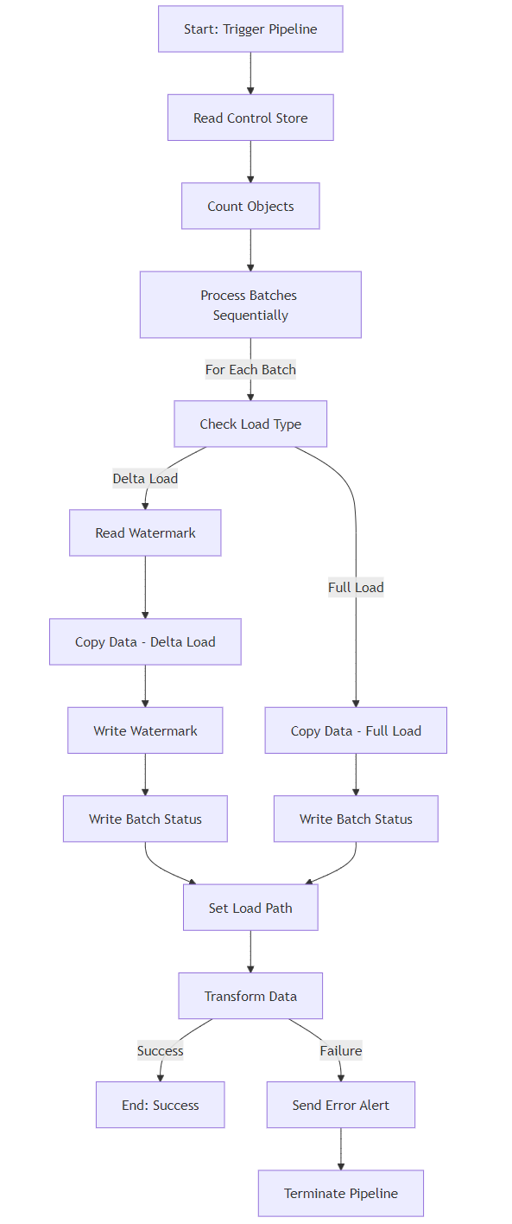
- Source Data Connection: Fabric connection to existing source systems using a gateway, with awareness of the ingestion patterns shown below
- Copy Data Activity: Utilising out-of-the-box connectors to extract data from sources and load it into the bronze area within MS Fabric using Pipeline Copy Activity and the ingestion patterns documented here.

Triggers

Schedule triggers
Schedule triggers in Microsoft Fabric are used to automate the execution of Fabric items like pipelines or notebooks at a specific time or on a recurring schedule. These triggers are ideal for running workflows or processes that must be executed consistently, such as daily data ingestion or weekly report generation.
A schedule trigger is directly attached to a specific Fabric item (e.g., a pipeline or a notebook) and executes that item based on the predefined schedule.

Storage triggers
Storage triggers in Microsoft Fabric initiate the execution of Fabric items (e.g., pipelines or notebooks) when specific events occur in storage, such as when files are created, updated, or deleted. These triggers are particularly useful for event-driven workflows, such as processing new data as soon as it is uploaded to a storage location.
Storage triggers are attached to Fabric items and rely on monitoring events in connected storage services to activate the corresponding workflows.

Ingestion control store
Below is a conceptual diagram showing the ingestion control store and how it interacts with Data pipelines within the platform.
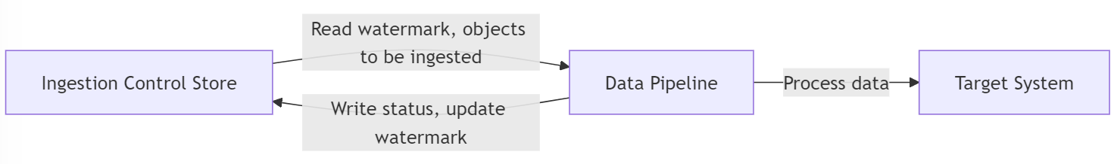
The Ingestion Control Store is named FDWH_IngestionControlStore located under the Workspace folder 09 Metadata / 03 Datawarehouses.
Section 8.1.1 Tools for Data Ingestion to Bronze contains details on how to add objects to this structure for ingestion.
Please see section 3.2.3.2 Ingestion control store schema for more details.

Watermark
To ensure that our data ingestion process is efficient and incremental, we will implement control tables with watermark logic and are hosted in Fabric SQL Database. Watermarks will help track the last successfully ingested records and ensure that only new or updated records are processed during subsequent runs. This approach minimises data duplication and optimises resource usage. Records are inserted into this table once notebook processing starts.

Ingestion control store schema
The details of the Microsoft Fabric Control Table schema that supports and tracks data ingestion pipelines over time are below.
Data within the control store is read prior to ingestion, and results are written back upon completion.
Control Table Column | Purpose
Id | Unique identifier for each control table record.
SourceObjectSettings | Configuration settings for the source object, including metadata and specific properties.
SourceConnectionSettingsName | Name of the connection settings used to access the source system.
CopySourceSettings | Settings related to how data is extracted from the source during the pipeline process.
SinkObjectSettings | Configuration settings for the sink object, defining where and how data is loaded.
SinkConnectionSettingsName | Name of the connection settings used to access the sink system.
CopySinkSettings | Settings related to how data is written to the sink during the pipeline process.
CopyActivitySettings | Detailed settings for the copy activity in the pipeline, such as transformations or mappings.
TopLevelPipelineName | Name of the pipeline orchestrating the data movement and transformation.
TriggerName | Name of the trigger that initiates the pipeline execution.
DataLoadingBehaviorSettings | Defines whether the data load is full load or delta load and the corresponding configurations.
CopyEnabled | Boolean flag to indicate whether the copy operation is enabled or disabled.

Standard control store functions
        - Stored Procedures

<Source>_MainControlTable_UpdateWatermarkColumnValue
This stored procedure updates the watermark date of a particular object in DeltaLoad or DeltaLoadWithQuery based on the latest watermark of the current ingestion.
Parameter Name | Description
watermarkColumnStartValue | The new watermark date to be written
Id | Id of the object whose watermark needs to be updated
Result: The watermark start value is updated at the end of an ingestion activity and is ready to be inspected by the next run.

ResetAllWatermarks, <Source>_ResetAllWatermarks
This stored procedure resets watermarks for all (or given) sources so that ingestion can restart. This is only intended to be run manually as an intervention.

Ingestion control store supporting functions
        - Stored Procedures

sp_InsertControlTableObject
The stored procedure sp_InsertControlTableObject is designed to facilitate the management and automation of data ingestion workflows within the Azure Data Factory environment. It dynamically inserts configuration details into the associated main control table based on the provided input parameters. This allows staff to add new objects to the table, which will be active upon next ingestion, with watermarks tracked (if applicable), and allows optional use of a watermark query.
This procedure streamlines data ingestion configuration by centralising various settings and behaviours, significantly reducing manual interventions and ensuring consistency in data pipeline executions. The stored procedure intelligently selects the target control table based on the input TableName, and then inserts comprehensive settings that govern source, sink, copy behaviours, and watermark management.
It automates critical aspects of data load activities, including source and destination definitions, copy behaviours, and data loading parameters such as incremental loading settings, providing support for delta or full data loading scenarios.
Parameter Name | Description
TableName | Identifies the target control table
SourceObjectSettings | JSON configuration defining the source object details (e.g., API name).
CopySourceSettings | JSON settings defining the copy source details (query-based data extraction settings).
SinkObjectSettings | JSON configuration defining the target sink storage settings (file name, file system).
DataLoadingBehavior | Determines the loading behaviour (e.g., Delta or Full load).
WatermarkColumnName | Column used to track incremental data loading (optional).
WatermarkQuery | SQL query to calculate the watermark date for incremental loading (optional).
This stored procedure configures and inserts entries into ingestion control tables, centralising the management of data ingestion processes and behaviours. It enables dynamic handling of pipeline configurations and supports incremental data loading through watermarking, facilitating efficient and scalable data ingestion operations.
        - Views

V_<Source>ControlTable
The purpose of the Control Table view is to provide a centralised view for managing and monitoring data ingestion processes across various source systems, for example, Salesforce or BAMC. It lists key configuration details to facilitate efficient and accurate data loading, ensuring consistency and reliability across ingestion workflows. The view supports streamlined data management by consolidating critical metadata such as source objects, associated queries, and loading behaviours.
The view captures essential attributes such as the type of data load (full or incremental delta), the source database objects involved, and queries used to extract or update the data. It also specifies watermark details, including columns and queries used to determine the most recent data loaded. This functionality enables precise tracking of data freshness and completeness, making it easier for teams to monitor data currency and quickly identify any potential issues or delays in the ingestion pipeline.
Overall, this structured representation enhances transparency and simplifies administration tasks, enabling data engineers and analysts to efficiently verify and validate the ingestion status. It serves as an essential reference point to ensure all datasets remain current, accurate, and readily accessible for downstream analytics and reporting requirements.
Column Name | Description
Id | Unique identifier for each ingestion configuration entry.
SourceObject | Name of the source object or table from which data is extracted.
SourceQuery | SQL query used to retrieve data from the source object.
DataLoadingBehaviour | Specifies the type of data load, e.g., FullLoad or DeltaLoad.
WatermarkColumn | Column used to identify the latest incremental data (if applicable).
WatermarkQuery | SQL query to retrieve the latest watermark value (if applicable).
LatestWatermarkValue | Timestamp indicating the last successful incremental load point.

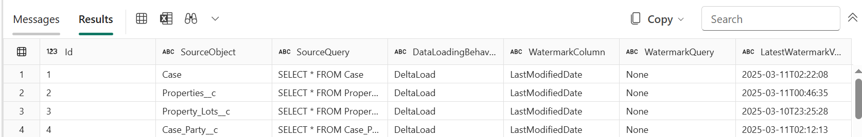
There are three levels of pipelines are within the metadata driven copy.

Metadata Driven Ingestion to Bronze

MetadataDrivenCopyTask_xxx_TopLevel
This pipeline will calculate the total number of objects (tables etc.) required to be copied in this run, come up with the number of sequential batches based on the max allowed concurrent copy task, and then execute another pipeline to copy different batches sequentially.
        - Parameters
Parameters name | Description
MaxNumberOfConcurrentTasks | You can always change the max number of concurrent copy activities run before pipeline run. The default value will be the one you input in copy data tool.
MainControlTableName | The table name of main control table. The pipeline will get the metadata from this table before run
ConnectionControlTableName | The table name of connection control table (optional). The pipeline will get the metadata related to data store connection before run
MaxNumberOfObjectsReturnedFromLookupActivity | In order to avoid reaching the limit of output lookup activity, there is a way to define the max number of objects returned by lookup activity. In most cases, the default value is not required to be changed.
windowStart | When you input dynamic value (for example, yyyy/mm/dd) as folder path, the parameter is used to pass the current trigger time to pipeline in order to fill the dynamic folder path. When the pipeline is triggered by schedule trigger or tumbling windows trigger, users do not need to input the value of this parameter. Sample value: 2021-01-25T01:49:28Z
        - Activities
Activity name | Activity type | Description
GetSumOfObjectsToCopy | Lookup | Calculate the total number of objects (tables etc.) required to be copied in this run.
CopyBatchesOfObjectsSequentially | ForEach | Come up with the number of sequential batches based on the max allowed concurrent copy tasks, and then execute another pipeline to copy different batches sequentially.
CopyObjectsInOneBtach | Execute Pipeline | Execute another pipeline to copy one batch of objects. The objects belonging to this batch will be copied in parallel.

MetadataDrivenCopyTask_xxx_ MiddleLevel
This pipeline will copy one batch of objects. The objects belonging to this batch will be copied in parallel.
        - Parameters
Parameters name | Description
MaxNumberOfObjectsReturnedFromLookupActivity | In order to avoid reaching the limit of output lookup activity, there is a way to define the max number of objects returned by lookup activity. In most case, the default value is not required to be changed.
TopLevelPipelineName | The name of top layer pipeline.
TriggerName | The name of trigger.
CurrentSequentialNumberOfBatch | The ID of sequential batch.
SumOfObjectsToCopy | The total number of objects to copy.
SumOfObjectsToCopyForCurrentBatch | The number of objects to copy in current batch.
MainControlTableName | The name of main control table.
ConnectionControlTableName | The name of connection control table.
        - Activities
Activity name | Activity type | Description
DivideOneBatchIntoMultipleGroups | ForEach | Divide objects from a single batch into multiple parallel groups to avoid reaching the output limit of the lookup activity.
GetObjectsPerGroupToCopy | Lookup | Get objects (tables, etc.) from the control table required to be copied in this group. The order of objects to be copied follows the TaskId in the control table (ORDER BY [TaskId] DESC).
CopyObjectsInOneGroup | Execute Pipeline | Execute another pipeline to copy objects from one group. The objects belonging to this group will be copied in parallel.

MetadataDrivenCopyTask_xxx_ BottomLevel
This pipeline will copy objects from one group. The objects belonging to this group will be copied in parallel.
        - Parameters
Parameters name | Description
ObjectsPerGroupToCopy | The number of objects to copy in current group.
ConnectionControlTableName | The name of connection control table.
windowStart | It used to pass the current trigger time to pipeline in order to fill the dynamic folder path if configured by user.
        - Activities
Activity name | Activity type | Description
ListObjectsFromOneGroup | ForEach | List objects from one group and iterate over each of them to downstream activities.
RouteJobsBasedOnLoadingBehavior | Switch | Check the loading behavior for each object. If it is default or FullLoad case, do full load. If it is DeltaLoad case, do incremental load via watermark column to identify changes
FullLoadOneObject | Copy | Take a full snapshot on this object and copy it to the destination.
DeltaLoadOneObject | Copy | Copy the changed data only from last time via comparing the value in watermark column to identify changes.
GetMaxWatermarkValue | Lookup | Query the source object to get the max value from watermark column.
UpdateWatermarkColumnValue | StoreProcedure | Write back the new watermark value to control table to be used next time.

More details on the metadata-driven copy framework
For more details on the metadata driven copy framework please see details in Microsoft documentation below:
Build large-scale data copy pipelines with metadata-driven approach in copy data tool - Microsoft

Source Connections and Service Accounts
All Bronze pipelines connect to the associated source systems either via Service Accounts created on-prem and Synced to EntraID or Service Principal. These utilise the @dpie.nsw.gov.au domain. The details are listed below.
Source System | Service Acc. Name  Non Prod | Service Acc. Name  Prod | Purpose
Salesforce | SVC-App-Salesforce-Fabric-nonPRD | SVC-App-Salesforce-Fabric-PRD | Connect to Salesforce Accounts that have read access to Salesforce objects
SharePoint | SVC-App-Sharepoint-Fabric-nonPRD | SVC-App-Sharepoint-Fabric-PRD | Read access to SharePoint Sites and/or individual files
ePlanning | N/A – Anonymous Access | N/A – Anonymous Access | All required access is satisfied via Anonymous/Public access to the API
BioNet | N/A – Anonymous Access | N/A – Anonymous Access | All required access is satisfied via Anonymous/Public access to the API
GOULBDB | Via DIO Connection 'DCCEEW Biodiversity Calculator [Non-Prod]' | Via DIO Connection 'DCCEEW Biodiversity Calculator [Prod]' | Read access to GOULBDB objects in the BiodiversityCalDB Schema
Planning | DPI-Datawarehouse-API-Access-dpt-DCCEEW-NON-PROD (Service Principal) | DPI-Datawarehouse-API-Access-dpt-DCCEEW-PROD | Connect to Planning API to authenticate and access API

Additionally, some Salesforce-specific user accounts are associated with the Salesforce service accounts. The mapping is shown below:
Salesforce EntraID Service Account | LMBC Salesforce Account
SVC-App-Salesforce-Fabric-nonPRD | svc-app-salesforce-fabric-nonprd@lmbc.com
SVC-App-Salesforce-Fabric-PRD | svc-app-salesforce-fabric-prd@lmbc.com

Ingestion from Bronze to Silver

Merge Bronze to Silver Pipeline
The L_MergeBronzeToSilver pipeline is designed to manage the data transition from the Bronze layer to the Silver layer within the Fabric environment. It uses a metadata-driven approach to apply transformations and execute Data Quality (DQ) checks as part of the ingestion process. The pipeline ensures that any data processed adheres to predefined quality standards and enforces error handling through conditional logic that validates DQ outcomes against a configurable tolerance threshold.
This pipeline is a reusable component that supports multiple ingestion use cases. Rather than creating separate pipelines for each data source, different master pipelines invoke L_MergeBronzeToSilver, passing specific parameters such as the data source type, batch ID, and Data Quality settings. This design promotes consistency and scalability across ingestion processes, enabling seamless integration of new data sources with minimal pipeline changes.
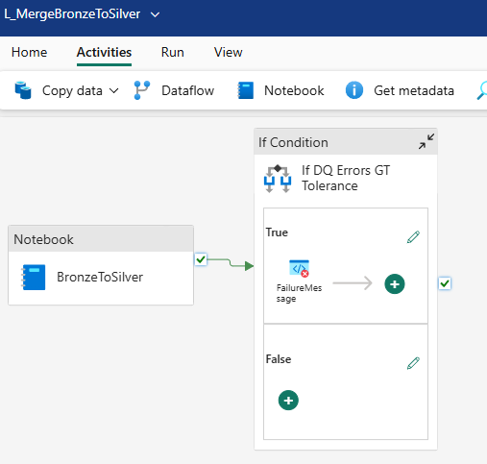

        - Parameters
Parameters name | Description
dataLoadBehaviour | Defines the use case to process, e.g. “Salesforce”, “goulbdb”
batchId | Passed from the Master pipeline as a string, representing the ingestion timestamp.
dqTolerance | Defines Data Quality tolerance, currently defaulted to 0.
dqEnabled | Defines whether Data Quality checks will run or not in the Notebook.
checkLastBatchStatus | Parameter used to check if the last ingestion was successful.
        - Activities
Activity name | Activity type | Description
BronzeToSilver | Notebook | Calls the Spark Notebook called N_BronzeToSilver, which processes the Merge from Bronze to Silver using the Metadata definitions from the SourceToTargetMapping, and performs Data Quality checks.
If DQ Errors GT Tolerance | If Condition | Checks if the Data Quality checks from the Notebook output are within the Data Quality Tolerance, using parameter dqTolerance to compare.
FailureMessage | Fail | Fails the pipeline with the message “Pipeline failed due to Notebook errors in Data Quality. X data quality errors found. Please see Fabric Notebook Snapshot for detailed error messages.”, where X is the value returned from the Notebook.

Ingestion from Silver to Gold

Merge Silver to Gold Pipeline
The L_MergeSilverToGold pipeline orchestrates the transition of data from the Silver layer to the Gold layer within the Fabric environment. It uses a modular design that dynamically selects the appropriate processing logic based on the sourceType parameter provided. Through a switch-case structure, the pipeline calls different notebooks tailored to each data source (e.g., Salesforce, SharePoint, BioNet), ensuring that each use case follows its specific transformation logic. Additionally, the pipeline includes logic to manage fact tables and retrieve and update the last batch ID to maintain ingestion tracking. Post-ingestion, it performs validation by querying the batch status to detect any failures in the Gold layer.
This pipeline is reused across all data ingestion scenarios by invoking it from various master pipelines with different parameters. Using parameters like sourceType and batchId allows the same pipeline to support a wide range of data sources and ingestion batches, promoting consistency and reducing redundancy. Built-in error handling ensures that any ingestion failures are captured and reported with detailed messages, improving transparency and simplifying troubleshooting.
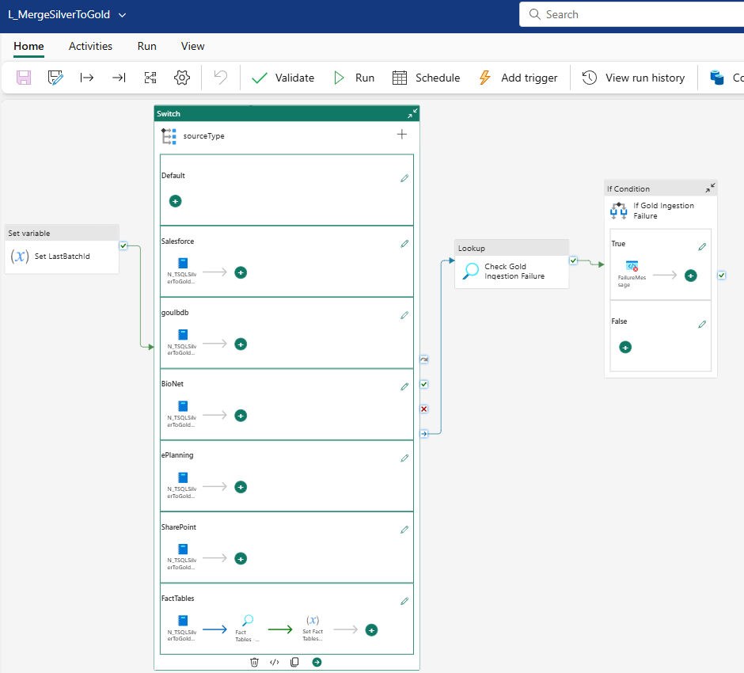
        - Parameters
Parameters name | Description
sourceType | Defines the data source type, e.g., "Salesforce", "goulbdb", "BioNet", etc.
batchId | Passed from the master pipeline; represents the batch ID used for the ingestion run.
        - Variables
Parameters name | Description
LastBatchId | Stores the batch ID for the current ingestion run. Initially set from the batchId parameter and may be updated dynamically (especially in the FactTables case) to reflect the last successful ingestion batch.
        - Activities
Activity name | Activity type | Description
Set LastBatchId | Set Variable | Initializes the LastBatchId variable using the provided batchId parameter.
sourceType | Switch | Determines which notebook to run based on the sourceType parameter (e.g., Salesforce, SharePoint, BioNet, FactTables).
N_TSQLSilverToGold_xxx | T-SQL Notebook | Executes the appropriate Spark notebook for the given data source to transform data from Silver to Gold. Each notebook is source-specific (e.g., Salesforce, SharePoint).
Fact Tables - Get Last Batch Id | Lookup | For the FactTables case, retrieves the latest batch ID from the Gold management table to maintain tracking.
Set Fact Tables BatchId | Set Variable | Sets the LastBatchId variable based on the lookup result for FactTables.
Check Gold Ingestion Failure | Lookup | Validates whether any tables failed in the current Gold ingestion by querying the ingestion status from the Gold management table.
If Gold Ingestion Failure | If Condition | Evaluates the result of the ingestion check; if failures are detected, it triggers an error message.
FailureMessage | Fail | Raises an error if Gold ingestion failures are found, with a message indicating which tables failed (populated dynamically from the lookup result).

Naming conventions
Below is a list of naming conventions used within the platform. The naming conventions standardize the assets and improve readability. Adhering to these conventions makes development using the platform streamlined and extensible.
Item | Naming convention
Fabric Data Factory Master Pipeline | M_PipelinePattern_PipelinePurpose
Fabric Data Factory Module Pipeline | L_ModulePipelinePurpose
Storage Pipeline Trigger | T_StorageTrigger_TriggerPurpose
Schedule Pipeline Trigger | T_ScheduleTrigger_TriggerPurpose
Variable | v_VariablePurpose
Parameter | p_ParameterPurpose
Linked Service | LS_LinkedServicePurpose
Fabric Notebook | N_NotebookPurpose_NotebookDataLayer
Fabric Data warehouse | FDWH_FabricDataWarehouseSourceName
Fabric Lakehouse | FLH_FabricLakehouseSourceName

Further Information:
Item | Naming convention
PipelinePattern | One of:  - semi-structured  - tabular data stream (TBS)  - custom
NotebookDataLayer | One of:  - bronze  - silver  - gold

Data Ingestion Patterns
While the platform is capable of several patterns, three master patterns were introduced initially to accommodate the initial set of use cases.
Each of the patterns has a master pipeline associated with it - Naming convention: P_patternName
Master pipelines are a collection of module pipelines constructed to enable a data ingestion pattern.
The following ingestion patterns were selected for the platform and are detailed further in this section:
- Semi-structured (JSON) ingestion pattern
- Tabular data stream ingestion pattern
- Custom – Salesforce data

Semi-structured data ingestion pattern
This section refers to the ingestion patterns developed for semi-structured data which is usable for the following formats:
- JSON: Commonly used for APIs and log data.
- XML: Used in legacy systems and industry-specific applications.

Copy data activity details
        - Source
Source Attribute | Details
Type | Azure Blob Storage, Azure Data Lake Storage, Amazon S3, or APIs.
Format | JSON, XML, Parquet, Avro, or CSV.
Configuration | Schema inference for flexible schema handling, Delimiter settings for CSV, Encoding options.
Compression | Supports Gzip, Snappy, and Bzip2 for compressed source files.
Authentication | OAuth 2.0 for APIs, Shared Key for Blob storage, or Access Keys for AWS S3.
        - Sink
Attribute | Details
Type | Fabric Data Warehouse  Fabric Lakehouse  Other: Azure Data Lake Storage, Azure SQL Database, Synapse Analytics, or Dataverse.
Format | Parquet (preferred for analytics), JSON, or CSV.
Partitioning | By date, region, or custom columns for optimized performance.
Compression | Gzip or Snappy for smaller data sizes and faster querying.
Configuration | Auto-mapping for schema alignment or custom column mapping for structured output.

Pipeline parameters
Name | Type | Example Value | Purpose
SourcePath | String | "/data/semi-structured/" | Specifies the source folder or file path in the storage account.
SourceFileFormat | String | "JSON" | Defines the format of the source data (e.g., JSON, XML, CSV, etc.).
SinkPath | String | "/processed/data/" | Specifies the target folder or file path where the ingested data will land.
SinkFileFormat | String | "Parquet" | Defines the format for the transformed data in the sink location.
CompressionType | String | "Gzip" | Specifies the compression method for the output data.
SchemaMapping | String (JSON) | "{source_field: target_field}" | Enables custom schema mapping between source and sink fields.
PartitionKey | String | "date" | Used for partitioning data in the sink based on specific keys.
MaxConcurrentCopies | Integer | 4 | Sets the maximum parallel copy activities to improve performance.
RetryCount | Integer | 3 | Specifies the number of retries for transient failures during data copy.
TriggerType | String | "Manual" or "Scheduled" | Determines whether the pipeline runs manually or on a schedule.

Master pipelines for Semi-structured data
Master pipeline name | Description
P_ePlanning_Ingestion_Master | Orchestrates the end-to-end ingestion process for ePlanning data sources.
P_BioNet_Ingestion_Master | Orchestrates the end-to-end ingestion process for BioNet data sources.
P_Planning_Ingestion_Master | Orchestrates the end-to-end ingestion process for Planning data sources.

        - P_ePlanning_Ingestion_Master
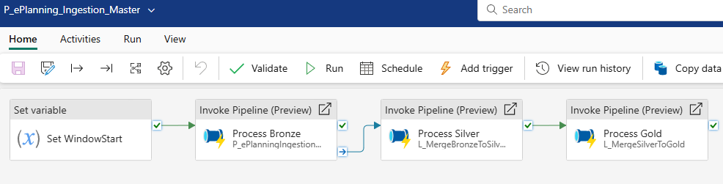
        - P_BioNet_Ingestion_Master
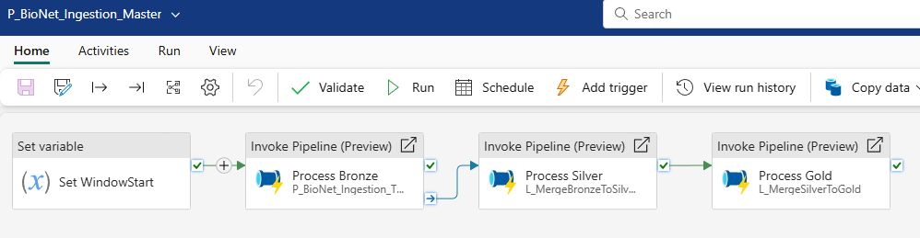
        - P_Planning_Ingestion_Master
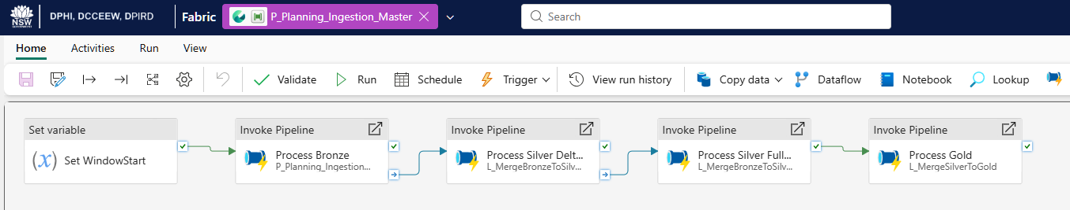

Data pipeline modules for Semi-structured data
Module Name | Description
L_BioNet_Load_From_API_Endpoint | The Bottom Level for BioNet runs this pipeline to ingest from the API endpoint for each defined ingestion object.
L_BioNetToBronze | Runs the Top, Middle and Bottom Level pipelines for BioNet. See 3.1.4. Metadata Driven Copy for more details.
L_BioNetIngestion_BottomLevel | Orchestrates the Bottom-Level load (individual object load) for BioNet. For more details, see 3.1.4. Metadata-Driven Copy.
L_BioNetIngestion_MiddleLevel | Orchestrates the Middle-Level load (send objects in batches to the Bottom Level) for BioNet. See 3.1.4. Metadata-Driven Copy for more details.
L_ePlanning_Load_From_API_Endpoint | The Bottom Level for ePlanning runs this pipeline to ingest from the API endpoint for each defined ingestion object.
L_ePlanning_ToBronze | Runs the Top, Middle, and Bottom-Level pipelines for ePlanning. For more details, see 3.1.4. Metadata-Driven Copy.
L_ePlanningIngestion_BottomLevel | Orchestrates the Bottom Level (individual object load) for ePlanning. See 3.1.4. Metadata Driven Copy for more details.
L_ePlanningIngestion_MiddleLevel | Orchestrates the Middle Level load (send objects in batches to Bottom Level) for ePlanning. See 3.1.4. Metadata Driven Copy for more details.
L_ePlanningToSilver | Runs L_MergeSilverToGold for ePlanning
P_Planning_Ingestion_TopLevel | Runs the top level load for Planning (distribute objects into batches for ingestion) See 3.1.4. Metadata Driven Copy for more details.
L_PLANIngestion_MiddleLevel | Orchestrates the Middle Level load (send objects in batches to Bottom Level) for Planning. See 3.1.4. Metadata Driven Copy for more details.
L_PLANIngestion_BottomLevel | Orchestrates the Bottom-Level load (individual object load) for Planning. For more details, see 3.1.4. Metadata-Driven Copy.
L_MergeBronzeToSilver | Runs the Bronze to Silver PySpark Notebook. See section Python Spark Notebooks for more details
L_MergeSilverToGold | Runs the Silver to Gold TSQL Notebook. See section TSQL Notebooks for more details

Tabular data stream (TDS) data ingestion pattern
This section refers to the ingestion patterns developed for tabular data streams, which are usable for the following examples:
- Relational Databases: e.g. SQL Server, Oracle, MySQL, PostgreSQL.
- Data Warehouses: e.g. Azure Synapse Analytics, Snowflake, Redshift.

Copy data activity details
        - Source
Source Attribute | Details
Type | Relational Databases (e.g., SQL Server, MySQL, PostgreSQL)
Format | Tabular data formats such as tables, views
Configuration | Uses SQL queries or table selections for extracting data.
Compression | It is not typically required but is supported for flat files (e.g., Zip).
Authentication | SQL authentication, Azure AD, or Shared Key for secure access.
        - Sink
Attribute | Details
Type | Fabric Data Warehouse  Fabric Lakehouse  Other: Azure SQL Database, Azure Synapse Analytics, or Data Warehouses.
Format | Delta Lake  Other: Tabular formats (e.g., Tables) or Parquet for analytical purposes.
Partitioning | Based on date, region, or other business logic for optimized querying.  Based on Source
Compression | Delta Parquet  Optional compression for analytical workloads (e.g., Snappy or Gzip).
Configuration | Column mappings or auto-schema mapping for seamless integration.

Pipeline parameters
Name | Type | Example Value | Purpose
p_SourceTableName | String | "ObjectData" | Specifies the table to extract data from in the source database.
p_SourceQuery | String | "SELECT * FROM Object" | Custom SQL query to extract required data.
p_SinkTableName | String | "ProcessedObjectData" | Specifies the destination table in the target database.
p_BatchSize | Integer | 10000 | Defines the number of records to copy in a single batch.
p_RetryCount | Integer | 3 | Specifies retry attempts in case of transient errors.
p_TriggerType | String | "Scheduled" | Determines the pipeline trigger type.
p_SchemaMapping | String (JSON) | "{source_column: target_column}" | Maps source columns to target columns.

Master pipelines for Tabular Data Streams
Master pipeline name | Description
P_GOULBDB_Ingestion_Master | Orchestrates the end-to-end ingestion process for GOULBDB data sources.
P_SalesForce_Ingestion_Master | Orchestrates the end-to-end ingestion process for SalesForce data sources.
P_SharePoint_Ingestion_Master | Orchestrates the end-to-end ingestion process for SharePoint data sources.
P_Gold_Ingestion_Master | Orchestrates the data load process for Fact Tables once other sources have completed synchronisation
P_Metadata_Ingestion_Master | Orchestrates the data load process for Metadata including SourceToTargetMapping
        - P_GOULBDB_Ingestion_Master
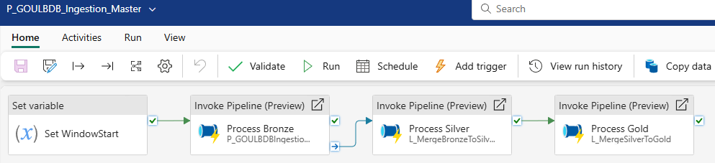

        - P_SalesForce_Ingestion_Master
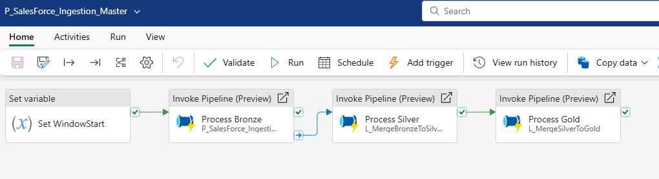
        - P_SharePoint_Ingestion_Master
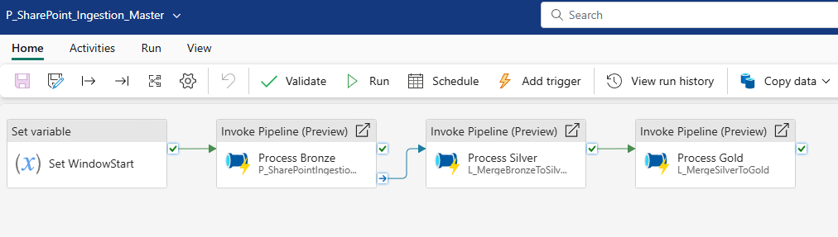
        - P_Gold_Ingestion_Master
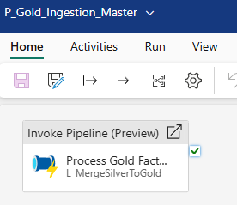
        - P_Metadata_Ingestion_Master
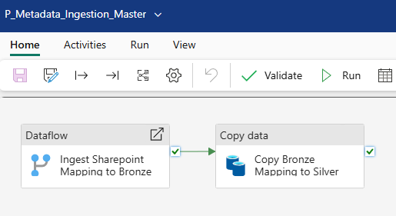

Module pipelines for Tabular Data Streams
Module Name | Description
L_GOULBDBIngestion_BottomLevel | Orchestrates the Bottom Level (individual object load) for GOULBDB. See 3.1.4. Metadata Driven Copy for more details.
L_GOULBDBIngestion_MiddleLevel | Orchestrates the Middle Level load (send objects in batches to Bottom Level) for GOULBDB. See 3.1.4. Metadata Driven Copy for more details.
L_MergeBronzeToSilver | Runs the Bronze to Silver PySpark Notebook. See section Python Spark Notebooks for more details
L_MergeSilverToGold | Runs the Silver to Gold TSQL Notebook. See section TSQL Notebooks for more details
L_SFAddObjectColumnMetadata | Dynamically retrieves the columns per Salesforce Object for use in the Metadata Driven Copy to Bronze
L_SFIngestion_BottomLevel | Orchestrates the Bottom Level (individual object load) for Salesforce. See 3.1.4. Metadata Driven Copy for more details.
L_SFIngestion_MiddleLevel | Orchestrates the Middle Level load (send objects in batches to Bottom Level) for Salesforce. See 3.1.4. Metadata Driven Copy for more details.
L_WriteDataflowBatchId | Part of the SharePoint Bronze ingestion process to allow parameterisation of the dataflow's individual BatchId
L_SharePointToBronze | Runs the Bronze Dataflow Ingestion Pipeline for SharePoint data sources (DF_SharePoint_ToBronze, shown below)

Dataflow V2
Master pipeline name | Description
  DF_SharePoint_ToBronze
  Conducts the initial ingestion process for SharePoint sources

Metadata Structure
Metadata is part of the Data Ingestion Framework and ensures data traceability, governance, and reusability across ingestion patterns. The metadata structure aligns with specific ingestion patterns, dictating which metadata attributes to populate at various stages. This approach enables modularity and enhances the maintainability of pipelines, notebooks, and stored procedures.
In file-based ingestion, object-level metadata such as file hashes and file sizes will be captured. Metadata attributes like creation and modification timestamps will be included for record-level ingestion to support fine-grained data governance and traceability.
The following metadata columns will be added to the Fabric SQL Database to support these objectives:
Metadata Column | Purpose
Record Created Timestamp | Indicates when the record was originally created in the source system.
Record Modified Timestamp | Indicates when the record was last modified in the source system.
Ingested file hash | Hash alphanumerical Identifier of the file that the record originated from (hash number has a 1-to-1 relationship with a unique file)
Ingested file size | Size of the ingested file that the record originated from
Ingestion Timestamp | Indicates when the record was ingested into the Microsoft Fabric environment.
Source Database | Identifies the source database or system where the record originates.
Source Schema | Identifies the schema or system of origin for the record (e.g., Salesforce).
Source Column | Specifies the column in the source system where the data originates.
Target Database | Identifies the target data product, database, or system as the ingestion target.
Target Schema | Specifies the schema or system where the data will be stored in Fabric.
Target Column | Specifies the column in the target system where the data is stored post-ingestion.
Transformation | Documents any transformations applied to the data during ingestion or processing.
Record Status | Indicates the status of the record (e.g., active, inactive) to support governance.
By explicitly capturing metadata at both object and record levels, the framework ensures robust traceability and enhances the effectiveness of ingestion processes across diverse data scenarios.

Data Persistence/Medallion Architecture

Bronze Layer
The Bronze layer stores raw data, holding unprocessed data directly ingested from the Source. This layer ensures data availability and supports reprocessing if needed.
Bronze Lakehouse Structure | Format | Persistence
Lakehouse with Schema and Table  -3 part identifier (Lakehouse.Schema.Table) | Tabular data stored in Delta Table | Permanent (Manual Storage Life Cycle Management can be applied)
*YYYY/MM/DD follows UTC time

Silver Layer
The silver layer contains cleaned and transformed data that is ready for analysis. Data in this layer undergoes validation, standardisation, and enrichment processes to ensure consistency and quality.
Silver Lakehouse Structure | Format | Persistence
Lakehouse with Schema and Table  -3 part identifier (Lakehouse.Schema.Table) | Tabular data stored in Delta Table | Permanent (Manual Storage Life Cycle Management can be applied)

Silver Layer Data Model Naming Conventions
        - Table Naming Convention
Component | Format/Description | Example
Table Type | Cleansed data | -
Entity Name | Specifies/identifies the cleaned data source | Account, CaseParty
Table Naming | Pascal Case, no underscores or special characters | Account, Contact
        - Column Naming Convention
Component | Format/Description | Example
Attribute Name | Column name in Pascal Case, no underscores or special characters | BillingCity, PersonEmail

Load methods for the Silver layer
The options for implementing delete and insert logic within the silver layer are detailed in the section below.
        - Delete and Insert Logic
- Pipeline: Managing delete and insert operations directly within the ingestion pipeline ensures a streamlined process but may increase the pipeline's complexity.
- Notebooks: Handling these operations within notebooks allows for more flexible and detailed data management, albeit with a potential increase in processing time.
        - Merge Logic
Alternatively, a merge strategy can be used based on the scenario. In this strategy, data is merged based on unique identifiers to update existing records and insert new ones. This method simplifies the data integration process by reducing redundant operations.

Gold layer
The Gold layer contains refined, aggregated, and business-ready data optimized for reporting, advanced analytics, and decision-making. It supports multiple modelling approaches tailored to specific use cases, with the current schema primarily following dimensional modelling principles where applicable. Note: While Microsoft Fabric supports large-scale data processing, it currently has limitations in fully implementing certain traditional dimensional modelling features (e.g., enforced relationships and surrogate keys), due to its optimisation for scale and performance.

Modelling methodology
The dimensional modelling methodology was selected for the gold layer of the data warehouse to ensure a user-centric, performance-optimised, and scalable design tailored to business intelligence needs.
The methodology focuses on delivering an intuitive and user-friendly data warehouse. Organising data into business-oriented dimensional models aligns with how users naturally think and query data, enabling faster insights and improved organisational decision-making.
The approach emphasises denormalised star schemas, which are highly optimised for query performance. This ensures that complex analytical queries and reporting processes run efficiently, providing timely access to critical business information without sacrificing performance.
The methodology supports an iterative, bottom-up approach to data warehouse design. This allows value delivered incrementally by focusing on high-priority business processes while maintaining flexibility for future enhancements and scaling to additional data sources and requirements.

Gold Layer Data model naming conventions
        - Table Naming Convention
Component | Format/Description | Example
Table Type | Specifies the type, e.g., Dim (dimension) or Fact (fact table) | Dim, Fact
Entity Name | Specifies the business entity | Account, CaseParty
Full Table Name | [TableType][EntityName] | DimAccount
        - Column Naming Convention
Component | Format/Description | Example
Entity Prefix (Optional) | Add entity name prefix for clarity, if needed | Account
Attribute Name | Column name in PascalCase | BillingCity, PersonEmail
Primary Key | [EntityName]Key | AccountKey
Foreign Key | [ReferencedEntity]Key | CustomerKey
        - Dimension Tables (Dim)
Component | Format/Description | Example
Table Name | Dim[EntityName] | DimAccount
Description | Represents descriptive attributes | Gold DimAccount
Primary Key | [EntityName]Key | AccountKey
        - Fact Tables (Fact)
Component | Format/Description | Example
Table Name | Fact[ProcessOrEvent] | FactSales
Description | Represents transactional data or measures | Gold FactSales
Primary Key | Include keys linking to dimensions | AccountKey
Measures | Include additive measures like amounts or counts | SalesAmount
        - General Notes
Aspect | Details
Case Style | Use PascalCase for column names and underscores for table names.
Abbreviations | Avoid unless well-known, e.g., ETL, ID.
Nullable Columns | Use standard naming but document nullable fields in metadata (e.g., Opt_ prefix if necessary).
Documentation | Maintain a data dictionary for traceability and relationships.

Usage of Temp_Reporting_ schemas
During Stage 1 of the project, the scope was limited to re-linking existing reports. However, it was identified that many of the reports had deviated from the central Data Warehouse and were instead directly connected to various source systems, including SharePoint files.
To support the re-linking without uplifting the reports themselves—something that was explicitly out of scope—it was agreed that all required data sources would be ingested into Microsoft Fabric in their current form. Since these sources do not conform to the standards established for the Fabric Data Warehouse, a decision was made to load them into a temporary schema structure: TempReporting_<Source> (e.g., TempReporting_BioNet, TempReporting_SharePoint).
This interim solution enables reporting to continue without delay, by allowing reports to connect to these temporary tables while ingestion and transformation up to the Silver layer proceed independently of the finalised data model. While this approach maintains delivery momentum, it is not aligned with long-term standards and must be remediated in subsequent phases—particularly for SharePoint sources, which require closer attention due to their format and structure.
Key aspects of the interim strategy:
- Naming Convention: TempReporting_<Source> (e.g., TempReporting_SharePoint)
- Purpose: Enables short-term report re-linking without requiring immediate report redevelopment
- Limitation: Sources are not aligned with Fabric Data Warehouse standards
- Next Steps: Migration to standardized schemas and full data model alignment in a future phase
This approach was confirmed and finalised following discussions with stakeholders. Refer to Decision: BioNet, Sharepoint and ePlanning Data persistence - Temporary Schema for more details.

Data model
In Microsoft Fabric, relationships between tables are not enforced. The diagrams below are provided for illustration purposes only.
Note: the 1-to-1 relationships shown are a default artifact of the diagramming tool and do not represent actual cardinality in the data model.

Presentation_LMBC

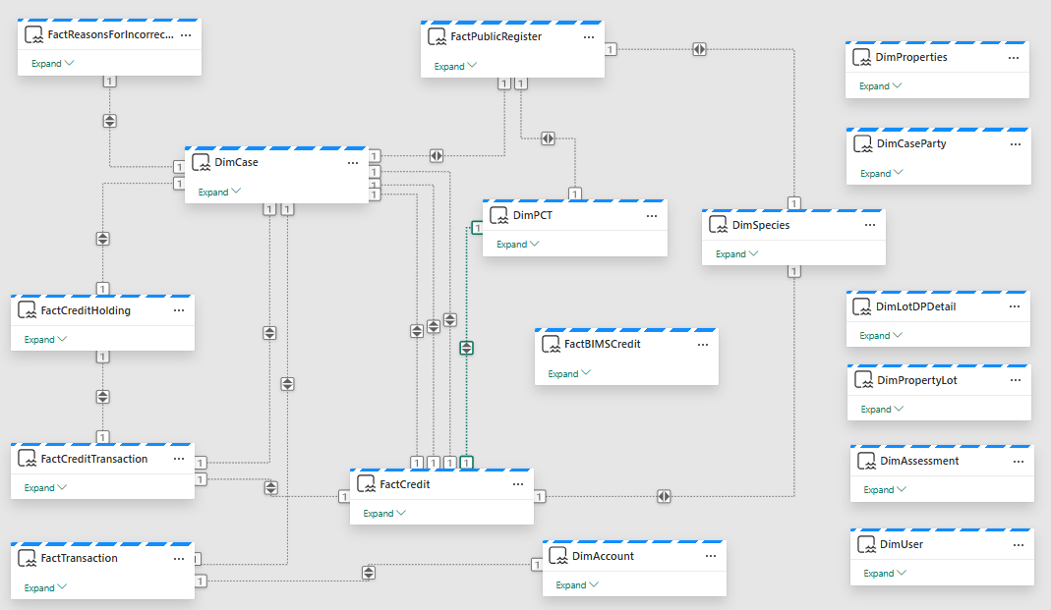

TempReporting_BioNet
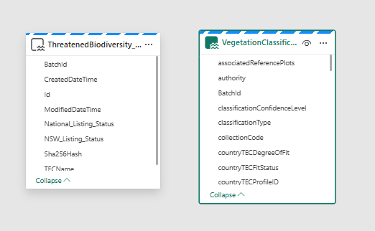

TempReporting_ePlanning
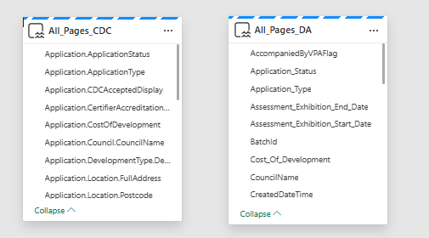

TempReporting_SharePoint
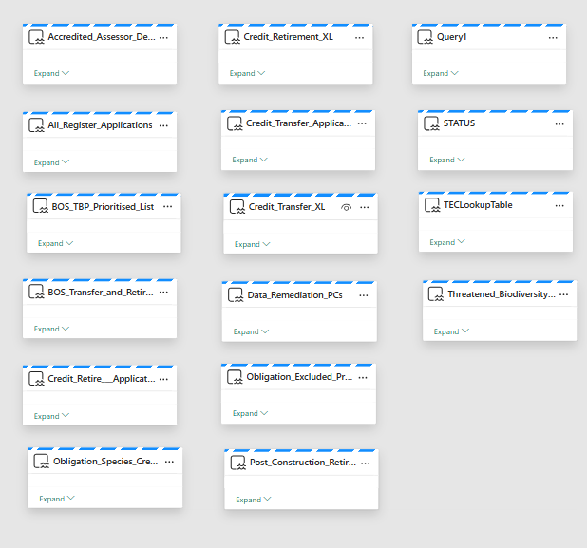

Fabric layer storage concepts

Fabric Lakehouse
By default, all data layers (Bronze, Silver, and Gold) are stored within OneLake. This centralised storage approach provides several advantages:
- Unified Data Management: A single repository for all data layers simplifies data governance and management.
- Scalability: OneLake’s scalable architecture supports growing data volumes and varying workload demands.
- Accessibility: Centralised storage ensures easy access to data for analysis and reporting across different layers.
Fabric Lakehouses are data structures in Fabric that point to tables in Delta format stored in OneLake. Read-only TSQL functionality over the Lakehouse data is provided by the SQL Analytics Endpoint.
Note that modifying data in a Lakehouse table requires a Notebook connected over the Delta table’s Python/Spark endpoints.
        - Lakehouses in Bronze
Bronze Lakehouse | Purpose
FLH_Bronze | Serves as the raw data storage, holding unprocessed data directly ingested from the Source in a tabular format

        - Lakehouses in Silver
Silver Lakehouse | Purpose
FLH_Silver | Contains cleaned and transformed tabular data, ready for analysis. Data undergoes validation, standardization, and enrichment processes.

Fabric Datawarehouses
        - Datawarehouses in Gold
Gold Datawarehouse | Purpose
FDWH_Gold | The Gold DWH holds refined, aggregated, and business-ready tabular data

Data Transformation

Spark Pools
Spark notebooks utilise the Spark pools based on the sizing specification inherited from the Fabric Capacity. A single F4 Capacity was provided across the Non-Prod and Prod environments.
Environment | Compute based on Capacity SKU | Purpose
Non-Prod | F4 | Conduct transformations within Spark notebooks for the Development (Non-Prod) environment
Prod | F4 | Conduct transformations within Spark notebooks for the Production environment

Python Spark notebooks
Notebook | Purpose | Part of Pipeline
N_BronzeToSilver | Conduct Spark transformations on Bronze Lakehouse data to be able to load cleaned and structured data into the Silver layer | L_MergeBronzeToSilver
N_CommonUtils | A set of common functions used with the notebook N_BronzeToSilver | -
N_DataQuality | A set of data quality functions used with the notebook N_BronzeToSilver | -

TSQL notebooks
Notebook | Purpose | Part of Pipeline
N_TSQLSilverToGold_BioNet | Loads data from Silver to Gold for the BioNet source based on the input SourceType and associated BatchId | L_MergeSilverToGold
N_TSQLSilverToGold_ePlanning | Loads data from Silver to Gold for the ePlanning source based on the input SourceType and associated BatchId | L_MergeSilverToGold
N_TSQLSilverToGold_FactTables | Loads data from Silver to Gold for the FactTables source based on the input SourceType and associated BatchId | L_MergeSilverToGold
N_TSQLSilverToGold_GOULBDB | Loads data from Silver to Gold for the GOULBDB source based on the input SourceType and associated BatchId | L_MergeSilverToGold
N_TSQLSilverToGold_Salesforce | Loads data from Silver to Gold for the Salesforce source based on the input SourceType and associated BatchId | L_MergeSilverToGold
N_TSQLSilverToGold_SharePoint | Loads data from Silver to Gold for the SharePoint source based on the input SourceType and associated BatchId | L_MergeSilverToGold
N_TSQLSilverToGold_Planning | Loads data from Silver to Gold for the Planning source based on the input SourceType and associated BatchId | L_MergeSilverToGold

Spark notebook flow
Stage 1 – Read Source to Memory
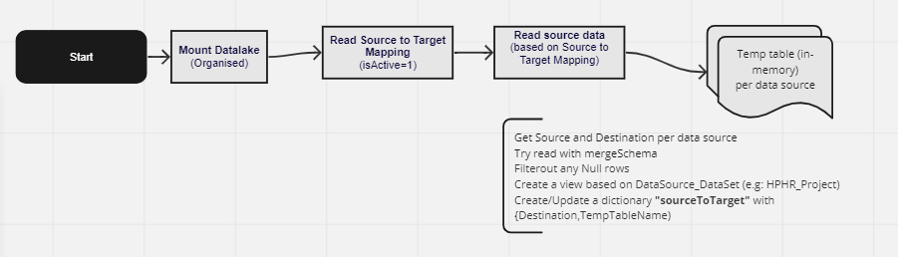
Stage 2 – Apply Transformations
The transformations are applied to each item in the sourceToTarget dictionary.
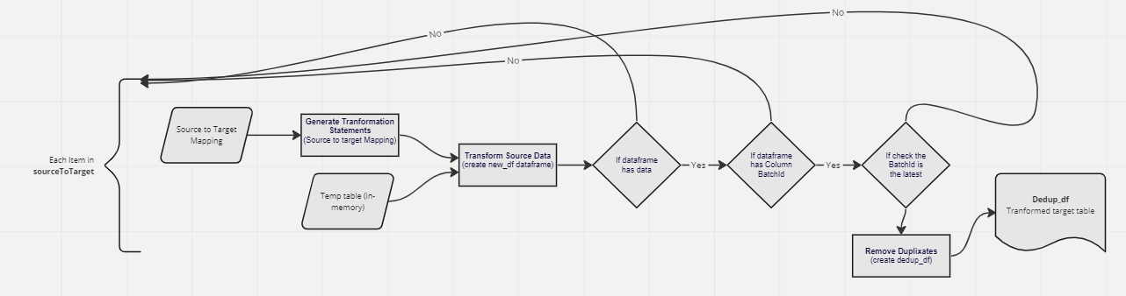
Stage 3 – Data Quality
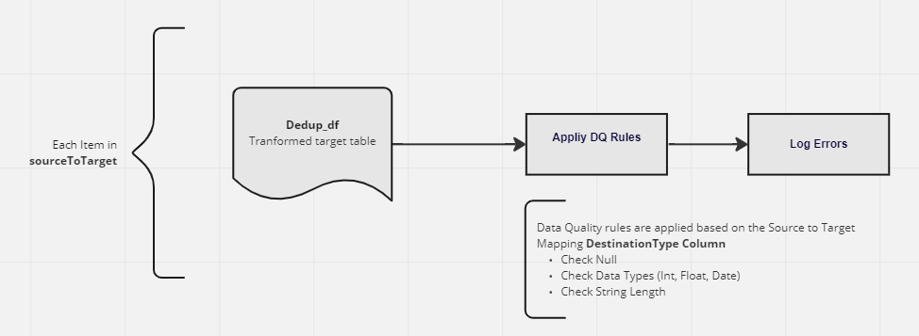
Stage 4 – Write to Staging
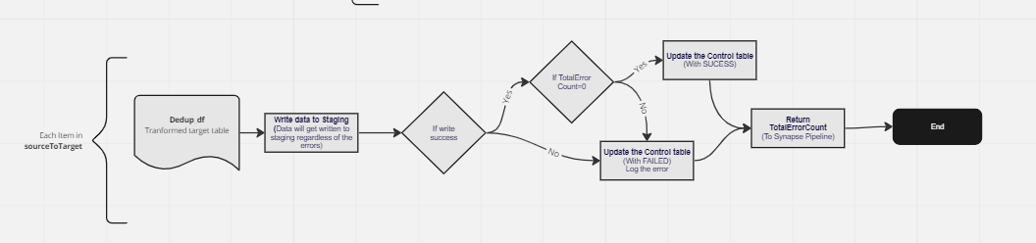

Post-ingestion/transformation processes

Stored Procedures
Post ingestion data, stored in Silver, is transformed and loaded to Gold Fabric Datawarehouse tables by a Stored Procedure. The stored procedures are shown below:
Schema | Stored Procedure | Details
BioNet | sp_IngestThreatenedBiodiversityEcologicalCommunities | Handles transformations and merge/load for IngestThreatenedBiodiversityEcologicalCommunities object for BioNet data
BioNet | sp_IngestVegetationClassificationPCTDefinition | Handles transformations and merge/load for IngestVegetationClassificationPCTDefinition object for BioNet data
mgmt | sp_GetBatchIdForIngestion | Handles data based on the latest BatchIds for the various gold destination tables
mgmt | sp_UpdateBatchStatus | Handles BatchIds for data based on the latest BatchIds for the various gold destination tables
Presentation_LMBC | sp_IngestDimAccount | Handles transformations and merge/load for IngestDimAccount object for Presentation_LMBC data
Presentation_LMBC | sp_IngestDimAssessment | Handles transformations and merge/load for IngestDimAssessment object for Presentation_LMBC data
Presentation_LMBC | sp_IngestDimCase | Handles transformations and merge/load for IngestDimCase object for Presentation_LMBC data
Presentation_LMBC | sp_IngestDimCaseParty | Handles transformations and merge/load for IngestDimCaseParty object for Presentation_LMBC data
Presentation_LMBC | sp_IngestDimLotDPDetail | Handles transformations and merge/load for IngestDimLotDPDetail object for Presentation_LMBC data
Presentation_LMBC | sp_IngestDimPCT | Handles transformations and merge/load for IngestDimPCT object for Presentation_LMBC data
Presentation_LMBC | sp_IngestDimProperties | Handles transformations and merge/load for IngestDimProperties object for Presentation_LMBC data
Presentation_LMBC | sp_IngestDimPropertyLot | Handles transformations and merge/load for IngestDimPropertyLot object for Presentation_LMBC data
Presentation_LMBC | sp_IngestDimSpecies | Handles transformations and merge/load for IngestDimSpecies object for Presentation_LMBC data
Presentation_LMBC | sp_IngestDimUser | Handles transformations and merge/load for IngestDimUser object for Presentation_LMBC data
Presentation_LMBC | sp_IngestFactBIMSCredit | Handles transformations and merge/load for IngestFactBIMSCredit object for Presentation_LMBC data
Presentation_LMBC | sp_IngestFactCredit | Handles transformations and merge/load for IngestFactCredit object for Presentation_LMBC data
Presentation_LMBC | sp_IngestFactCreditHolding | Handles transformations and merge/load for IngestFactCreditHolding object for Presentation_LMBC data
Presentation_LMBC | sp_IngestFactCreditTransaction | Handles transformations and merge/load for IngestFactCreditTransaction object for Presentation_LMBC data
Presentation_LMBC | sp_IngestFactPublicRegister | Handles transformations and merge/load for IngestFactPublicRegister object for Presentation_LMBC data
Presentation_LMBC | sp_IngestFactReasonsForIncorrectCategorisation | Handles transformations and merge/load for IngestFactReasonsForIncorrectCategorisation object for Presentation_LMBC data
Presentation_LMBC | sp_IngestFactTransaction | Handles transformations and merge/load for IngestFactTransaction object for Presentation_LMBC data
TempReporting_BioNet | sp_IngestThreatenedBiodiversity_EcologicalCommunities | Handles transformations and merge/load for IngestThreatenedBiodiversity_EcologicalCommunities object for TempReporting_BioNet data
TempReporting_BioNet | sp_IngestVegetationClassification_PCTDefinition | Handles transformations and merge/load for IngestVegetationClassification_PCTDefinition object for TempReporting_BioNet data
TempReporting_ePlanning | sp_IngestAll_Pages_CDC | Handles transformations and merge/load for IngestAll_Pages_CDC object for TempReporting_ePlanning data
TempReporting_ePlanning | sp_IngestAll_Pages_DA | Handles transformations and merge/load for IngestAll_Pages_DA object for TempReporting_ePlanning data
TempReporting_SharePoint | sp_IngestAccredited_Assessor_Details | Handles transformations and merge/load for IngestAccredited_Assessor_Details object for TempReporting_SharePoint data
TempReporting_SharePoint | sp_IngestAll_Register_Applications | Handles transformations and merge/load for IngestAll_Register_Applications object for TempReporting_SharePoint data
TempReporting_SharePoint | sp_IngestBCT_Offset_Obligations_Register_Retirements | Handles transformations and merge/load for IngestBCT_Offset_Obligations_Register_Retirements object for TempReporting_SharePoint data
TempReporting_SharePoint | sp_IngestBOS_TBP_Prioritised_List | Handles transformations and merge/load for IngestBOS_TBP_Prioritised_List object for TempReporting_SharePoint data
TempReporting_SharePoint | sp_IngestBOS_Transfer_and_Retirement_paid_TFD | Handles transformations and merge/load for IngestBOS_Transfer_and_Retirement_paid_TFD object for TempReporting_SharePoint data
TempReporting_SharePoint | sp_IngestCredit_Retire___Applications | Handles transformations and merge/load for IngestCredit_Retire___Applications object for TempReporting_SharePoint data
TempReporting_SharePoint | sp_IngestCredit_Retirement_XL | Handles transformations and merge/load for IngestCredit_Retirement_XL object for TempReporting_SharePoint data
TempReporting_SharePoint | sp_IngestCredit_Transfer_Applications | Handles transformations and merge/load for IngestCredit_Transfer_Applications object for TempReporting_SharePoint data
TempReporting_SharePoint | sp_IngestCredit_Transfer_XL | Handles transformations and merge/load for IngestCredit_Transfer_XL object for TempReporting_SharePoint data
TempReporting_SharePoint | sp_IngestData_Remediation_PCs | Handles transformations and merge/load for IngestData_Remediation_PCs object for TempReporting_SharePoint data
TempReporting_SharePoint | sp_IngestObligation_Ecosystem_Credits_XL | Handles transformations and merge/load for IngestObligation_Ecosystem_Credits_XL object for TempReporting_SharePoint data
TempReporting_SharePoint | sp_IngestObligation_Excluded_Projects_XL | Handles transformations and merge/load for IngestObligation_Excluded_Projects_XL object for TempReporting_SharePoint data
TempReporting_SharePoint | sp_IngestObligation_Species_Credits_XL | Handles transformations and merge/load for IngestObligation_Species_Credits_XL object for TempReporting_SharePoint data
TempReporting_SharePoint | sp_IngestPost_Construction_Retirement_XL | Handles transformations and merge/load for IngestPost_Construction_Retirement_XL object for TempReporting_SharePoint data
TempReporting_SharePoint | sp_IngestQuery1 | Handles transformations and merge/load for IngestQuery1 object for TempReporting_SharePoint data
TempReporting_SharePoint | sp_IngestSTATUS | Handles transformations and merge/load for IngestSTATUS object for TempReporting_SharePoint data
TempReporting_SharePoint | sp_IngestTECLookupTable | Handles transformations and merge/load for IngestTECLookupTable object for TempReporting_SharePoint data
TempReporting_SharePoint | sp_IngestThreatened_Biodiversity_Species | Handles transformations and merge/load for IngestThreatened_Biodiversity_Species object for TempReporting_SharePoint data
Planning | sp_IngestDimLocalPart4Document | Handles transformations and merge/load for DimLocalPart4Document object for Planning data
Planning | sp_IngestDimLocalPart4Location | Handles transformations and merge/load for DimLocalPart4Location object for Planning data
Planning | sp_IngestDimLocalPart4Lot | Handles transformations and merge/load for DimLocalPart4Lot object for Planning data
Planning | sp_IngestDimLocalPart4Subdivision | Handles transformations and merge/load for DimLocalPart4Subdivision object for Planning data
Planning | sp_IngestDimMajorProjectsDocument | Handles transformations and merge/load for DimMajorProjectsDocument object for Planning data
Planning | sp_IngestDimMajorProjectsEPBC | Handles transformations and merge/load for DimMajorProjectsEPBC object for Planning data
Planning | sp_IngestDimPart5Document | Handles transformations and merge/load for DimPart5Document object for Planning data
Planning | sp_IngestDimPart5Location | Handles transformations and merge/load for DimPart5Location object for Planning data
Planning | sp_IngestDimPart5Lot | Handles transformations and merge/load for DimPart5Lot object for Planning data
Planning | sp_IngestFactLocalPart4Application | Handles transformations and merge/load for FactLocalPart4Application object for Planning data
Planning | sp_IngestFactMajorProjectsApplication | Handles transformations and merge/load for FactMajorProjectsApplication object for Planning data
Planning | sp_IngestFactPart5Application | Handles transformations and merge/load for FactPart5Application object for Planning data

Alerting and Notifications

Alerting is provided by a single Fabric Data Activator (Reflex) item, Alerts_MasterPipelines, which raises a notification when a master data pipeline stops completing successfully. It is driven entirely by the pipeline monitoring solution described in Section 3.8: the daily collector notebook publishes the current master-pipeline status to an Event Hub, the ES_Pipeline_Monitoring eventstream forwards those events to the Activator, and the Activator evaluates them against one rule.
This replaces the earlier approach, in which separate Activator rules were configured against Fabric job events for each individual master pipeline and for each source-to-Bronze load. Those rules have been retired: alerting is now scoped to the single source and single rule documented below, which covers every pipeline the monitoring solution treats as a master pipeline rather than an enumerated list.

Alert source and object model
The Activator defines one object, master_pipelines, whose instances are identified by the ItemName field of the incoming event — that is, Activator tracks state separately for each master pipeline, keyed on the pipeline's item name. The eventstream is registered as an authoritative source and split on that field, so each event updates the state of exactly one pipeline instance.
A single attribute is monitored: master_status_tricolour, taken from the event payload and typed as text. This is the same three-way Success / Partial / Failed classification the report presents, computed upstream in the alert-state view rather than in the semantic model, so the alert and the report agree on a pipeline's status.
Setting | Value
Activator item | Alerts_MasterPipelines
Source | Eventstream — ES_Pipeline_Monitoring
Stream | ES_Pipeline_Monitoring-stream
Object | master_pipelines
Instance identifier | ItemName (text)
Monitored attribute | master_status_tricolour (text)

Alert rule
One rule is defined, ES_Pipeline_Monitoring-stream alert.
Setting | Value
Rule name | ES_Pipeline_Monitoring-stream alert
Event | ES_Pipeline_Monitoring-stream on the master_pipelines object
Condition | master_status_tricolour changes from Success
Occurrence | Each time the condition is met
Action | Microsoft Teams message
Recipients | Appropriate respondees
State | Active. The rule is also set to re-apply on update.
Because the condition is a change away from Success, a pipeline that moves from Success to either Partial or Failed will alert, and a pipeline that remains in a non-Success state across successive collections will not re-alert until its status changes again. As the upstream collection runs once daily at 08:00 AUS Eastern (Section 3.8.7), the practical alert cadence is at most once per day per pipeline.

Notification content
The Teams message headline names the failed pipeline (Master pipeline failed: <ItemName>). The message body carries the following fields from the event payload:
- ItemName — the master pipeline that failed
- checkedAtUtc — the time the monitoring collection observed the status
- pipelineRunId — the Fabric run ID, for lookup in Monitor
- failureReason_errorCode — the error code reported by Fabric
- failureReason_message — the failure detail, truncated upstream to 800 characters
- failed_children — the number of child activities that failed
- succeeded_children — the number of child activities that succeeded
The failed and succeeded child activity counts are what allow the recipient to distinguish a wholly failed pipeline from a partial failure directly from the notification, without opening the report.
Example Alert notification:
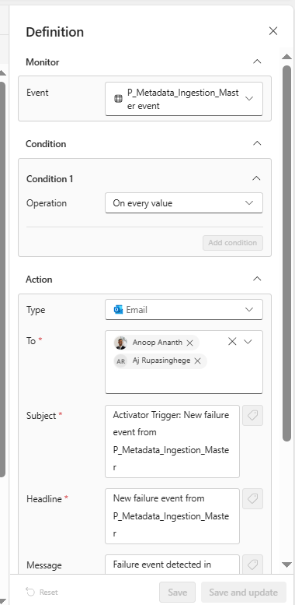

Pipeline Monitoring and Reporting
A dedicated pipeline monitoring and reporting solution has been implemented to provide operational visibility over the platform's scheduled data pipelines. It complements the event-driven alerting described in Section 3.7 by collecting pipeline run history into the platform itself, exposing it through a Power BI report, and publishing a daily master-pipeline status feed that drives the master pipeline alert. The solution is deployed in both the non-production and production environments.

Solution components
The solution is made up of the following Fabric items.
Item | Type | Purpose
N_mgmt_pipeline_monitoring | Notebook (Python) | Daily collector. Reads Fabric job instances, activity runs, pipeline definitions and scheduled-pipeline parameters from the Fabric REST API and merges them into Delta tables in the meta schema of FLH_Bronze. Also publishes the master-pipeline alert-state rows to an Event Hub.
P_Pipeline_Monitoring | Data Pipeline | Orchestration. Runs the collector notebook, then refreshes the pipeline_monitoring semantic model on success.
VL_Ingestion_Variables | Variable Library | Supplies the Event Hub namespace, hub name, SAS key name, Key Vault URL and secret name to the notebook at run time, so no environment-specific values are held in the notebook itself.
FLH_Bronze | Lakehouse | Hosts the meta schema: four Delta tables written by the notebook and the SQL views the semantic model reads (Sections 3.8.3 and 3.8.4).
ES_Pipeline_Monitoring | Eventstream | Receives the alert-state events published by the notebook on a custom endpoint and routes them to the Activator destination.
Alerts_MasterPipelines | Activator (Reflex) | Evaluates the master-pipeline status events against a single rule and sends the Teams notification (Section 3.7).
pipeline_monitoring | Semantic Model | Import-mode model over the meta views; supplies the report's measures.
pipeline_monitoring | Report | Five-page Power BI report (Section 3.8.6).

Collection notebook
N_mgmt_pipeline_monitoring enumerates the items in the target workspace of type DataPipeline, Notebook and Dataflow, retrieves their job instances for the lookback window, and then, for every pipeline that has at least one scheduled run in that window, queries the activity runs of each of its job instances. A pipeline with at least one scheduled run is what the solution treats as a “master” pipeline; manual re-runs of those same pipelines are retained, so an ad-hoc re-run can still be the latest run.
Activity runs are collected recursively: the Fabric queryactivityruns endpoint does not descend into child pipelines invoked by Invoke/Execute Pipeline activities, so child run IDs are extracted from activity output and queried in turn. Each row is annotated with its nesting depth, root run and parent run. Traversal is bounded to a maximum depth of 20 and 5,000 runs per root. REST calls are retried up to five times on HTTP 429, 500, 502, 503 and 504 with exponential backoff, honouring Retry-After where the response supplies it. Non-fatal problems are collected as warnings and printed in a summary at the end of the run rather than failing the notebook.
The notebook's parameters are set from the orchestration pipeline (Section 3.8.7); the defaults held in the notebook are as follows.
Parameter | Default | Notes
source_workspace | (blank) | Workspace to scan. Blank resolves to the workspace the notebook is running in.
target_workspace | (blank) | Workspace the meta tables are written to. Blank resolves to the source workspace.
target_lakehouse | FLH_Bronze | Lakehouse the meta tables are written to.
target_schema | meta | Target schema. Can be pointed at a scratch schema to trial changes without affecting the tables the report reads.
hours_lookback | 96 | Lookback window for job instances and activity runs.
eventhub_namespace | (blank) | Event Hub namespace for alert publication; supplied from VL_Ingestion_Variables.
eventhub_name | (blank) | Event Hub (hub) name.
eventhub_key_name | (blank) | Shared access key name.
eventhub_key_vault_url | (blank) | Key Vault URL the SAS key is read from.
eventhub_key_secret_name | (blank) | Key Vault secret name holding the SAS key.

Monitoring tables
The notebook writes four Delta tables into the meta schema of FLH_Bronze.
Table | Grain | Write mode
meta.pipeline_runs | One Fabric job instance | Upsert (merge) on id
meta.pipeline_activities | One activity run within a pipeline run | Upsert (merge) on activityRunId
meta.pipeline_params | Default sourceType per scheduled pipeline | Upsert (merge) on id
meta.pipeline_definitions | One activity in a pipeline definition (static topology) | Full overwrite. The previous snapshot is deliberately retained if the collection returned no rows, or if every pipeline failed to read, so that a bad sweep cannot replace a good snapshot with error rows.
The activity projection is a fixed, named column list of 21 columns covering identity and grain, status and timing, failure detail (error code, message, failure type, target), nesting context, and Copy activity throughput (rows read and rows copied).

Semantic layer views
The Delta tables are not read directly. Six SQL views in the meta schema, queried through the SQL analytics endpoint of FLH_Bronze, sit between the tables and the semantic model. The column names in the notebook, the view DDL and the semantic model form a single contract in three places.
View | Source table | Consumed by | Notes
meta.vw_pipeline_runs | pipeline_runs | Fact Pipeline Runs | One row per job instance; aliases id to pipelineRunId.
meta.vw_latest_master_pipeline_runs | pipeline_runs | Fact Latest Master Pipeline Runs | Most recent run of each master pipeline, selected by row number over start time. Also restricts the activity runs view.
meta.vw_pipeline_activity_runs | pipeline_activities | Fact Pipeline Activity Runs | Activity runs for master pipelines only; builds activity_key as pipelineId + '-' + activityName.
meta.vw_pipeline_definitions | pipeline_definitions | Fact Pipeline Definitions | Static activity topology; builds the matching activity_key from pipeline_id + '-' + activity_name. Both sides must build the key identically.
meta.vw_pipeline_ID_lookup | pipeline_definitions | Dim Pipeline | Pipeline id/name dimension. Sourced from definitions rather than runs so pipelines with no runs in the window still appear in slicers.
meta.vw_pipeline_params | pipeline_params | Dim Pipeline Source | Default parameter values for scheduled pipelines. ItemId and itemId are different columns and both are required — the warehouse collation is case-sensitive.
A seventh view, meta.vw_master_pipeline_alert_state, is queried by the notebook to build the alert events described in Section 3.8.7. Its definition is not currently held in the Azure DevOps repository — see Section 3.8.8.

Semantic model
pipeline_monitoring.SemanticModel is an import-mode model over the six views above. It contains four fact tables (Fact Pipeline Runs, Fact Latest Master Pipeline Runs, Fact Pipeline Activity Runs, Fact Pipeline Definitions), two dimensions (Dim Pipeline, Dim Pipeline Source) and a Measure Table holding 28 measures, plus an embedded Data Dictionary table.
The following measures carry the reporting logic and are the ones most likely to need attention in support.
Measure | Purpose
Master Status (TriColour) | The report's status classification. Passes through Failed, Not Started and Cancelled from the master run status; otherwise derives Success (no failed child activities, at least one succeeded), Partial (both failed and succeeded child activities) or Failed (failed child activities only) from the activity runs, falling back to Unknown.
Master Status Colour | Maps the tri-colour status to hex colours (green / amber / red / grey) for conditional formatting.
Is Latest Run, Latest Run Time | Identify and date the most recent run per pipeline item.
Total / Failed / Partial / Successful Master Pipelines, Success Rate % | Headline counts and success rate across the latest master pipeline runs.
Total Failed Activities, Total Activities (past 48 hours), Needs Attention | Activity-level failure counts and an attention flag.
Failed / Successful / Partial / Total KPI SVG, Failed Activities KPI SVG, Partial Failed Runs KPI SVG, Pipeline Flow SVG | Measures that emit SVG markup, rendered by the HTML content custom visual to produce the KPI tiles and the pipeline flow diagram.
Failure Summary, Duration (sec), Can Drill Through, Master Pipeline Failure (History) % | Supporting measures for the failure and history pages.

Report
pipeline_monitoring.Report presents the model across five pages.
Page | Purpose
Master Pipelines Overview | Landing page (default). Latest status of each master pipeline, KPI tiles, a success-rate gauge and the pipeline flow visual, with navigation buttons to the other pages.
Failed Master Pipelines | Trend and reliability view filtered to failed master pipeline runs.
Partial Activity Failure | Master pipeline runs where some, but not all, child activities failed — the Partial classification.
Failure Investigation | Drill-through detail for a selected failure, including error code, message, failure type and target.
All Pipeline Runs | Full master pipeline run history for the collection window.
The report uses the NSW Government theme and logo, and depends on an HTML content custom visual to render the SVG-based KPI tiles and flow diagram.

Orchestration, schedule and alert publication
P_Pipeline_Monitoring.DataPipeline runs two activities in sequence:
- N_mgmt_pipeline_monitoring — the collector notebook, with the Event Hub parameters supplied from VL_Ingestion_Variables. Timeout 12 hours, no retries.
- Pipeline Monitoring Refresh — a semantic model refresh of pipeline_monitoring, executed only on success of the notebook, transactional, waiting on completion.
The pipeline is scheduled daily at 08:00 AUS Eastern Standard Time, enabled from 3 August 2026. As a result, the monitoring tables, the report and the master-pipeline alert all refresh once per day, and the practical alert cadence for the master pipeline alert is at most daily regardless of the Activator's own evaluation frequency.
Alert event publication works as follows. After the tables are written, the notebook queries meta.vw_master_pipeline_alert_state through the lakehouse SQL endpoint and converts each row into a JSON event, adding an eventType of MasterPipelineRunStatus, a checkedAtUtc timestamp and an objectId set to the pipeline item name, and truncating the failure message to 800 characters. The events are posted to the Event Hub using a short-lived (300 second) shared access signature, with the signing key read from Key Vault at run time. A failure to publish is recorded as a warning and does not fail the notebook, so a successful collection is not lost because the alert feed was unavailable.
The Event Hub feeds the ES_Pipeline_Monitoring eventstream through a custom endpoint source, and the eventstream's single destination is Alerts_MasterPipelines, which raises the Teams notification (Section 3.7). The eventstream is configured with a retention of one day, a low event throughput level and no enforced schema. This retention has been confirmed as sufficient for the alerting use case.
Note that the fields the Activator rule and its notification reference — ItemName, master_status_tricolour, pipelineRunId, failureReason_errorCode, failureReason_message, failed_children and succeeded_children — must all be projected by meta.vw_master_pipeline_alert_state. Changing or renaming a column in that view is a breaking change to the alert as well as to the event payload.

Outstanding actions
The following actions remain outstanding against this section. The other details recorded above have been confirmed against the live Fabric workspace.
- Alert recipients. The Activator rule currently notifies a single individual recipient, which appears to be a value left from development. The intended audience is to be set by the business, and the recipient replaced with a Teams channel or distribution group.
- Alert-state view to be added to source control. The view meta.vw_master_pipeline_alert_state, which the notebook queries to build the alert events and which must project every field the Activator rule references, has no DDL in the Azure DevOps repository, unlike the other six meta views. Its definition is to be added to the repository.

Azure Repos

Repository details
Below are the details of the Azure DevOps Repo used for the project.
Item | Details
Organisation | nswdpie-cs-data-analytics
Project | DTP MS Fabric Data Consolidation and Enhancement Project
Repo | DTP MS Fabric Data Consolidation and Enhancement Project
Branches | dev, main
Board | DTP MS Fabric Data Consolidation and Enhancement Project Team
Link | DTP MS Fabric Data Consolidation and Enhancement Project

The Azure DevOps repo is used as a version control system for the following items:
- Fabric Pipelines
- Fabric Notebooks
- Fabric Alert definitions
- Fabric Lakehouses
- Fabric Datawarehouses
See also – Section 6 Continuous Integration & Deployment.

DevOps backlog
Additionally, an Azure DevOps backlog was used to track project activities during the implementation:
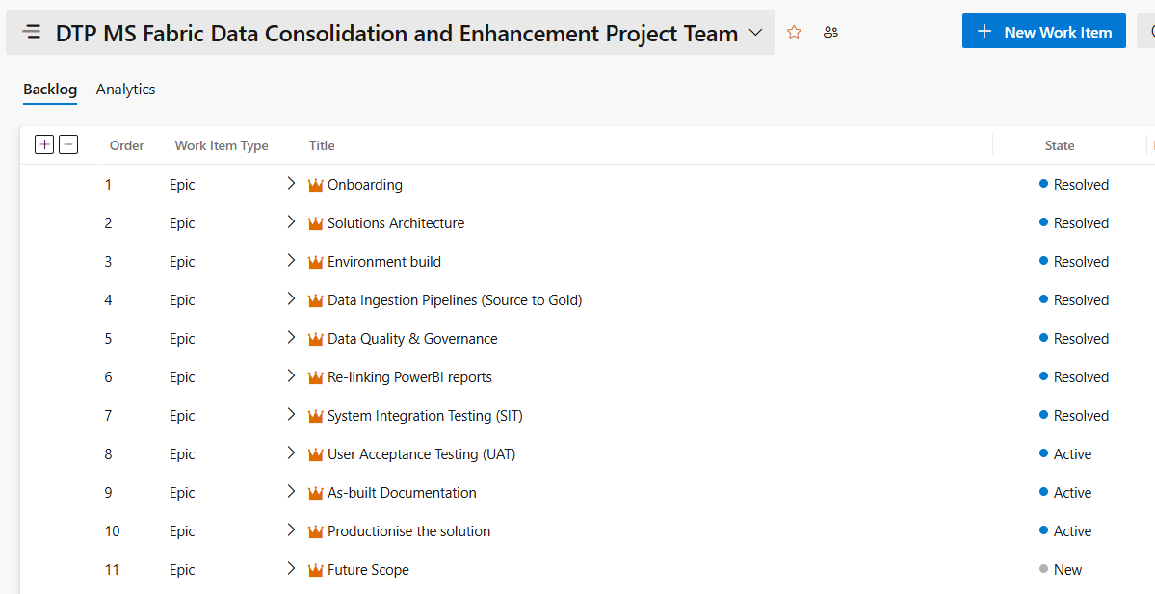

Platform Operational Pillars

Data Governance
Microsoft Fabric provides unified data services across the entire data lifecycle, with data governance and administration considered end-to-end. These services are applied to a common foundation comprising One Lake for centralised data storage, a unified security model under One Security. This integrated approach simplifies architecture, enhances collaboration, and accelerates time-to-insight across the enterprise. The diagram below shows more information about how Fabric’s native Data Governance is applied across the platform.
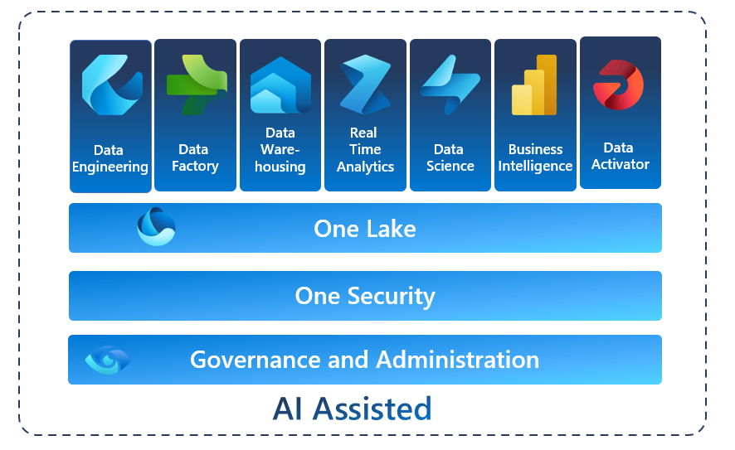
Data Governance and Administration in MS Fabric
In the implemented platform, Fabric’s Data governance is supplemented using a metadata-driven ingestion framework that captures and enforces rules for how data is sourced, processed, and tracked across the platform. Control tables define ingestion logic, including source/sink mappings, watermarking for incremental loads, and pipeline orchestration metadata. This ensures consistent, repeatable, and auditable data movement.
Governance information is captured and controlled via specific data structures. These include batch tracking, ingestion status, and metadata such as load type, timestamps, and schema definitions. This allows engineers to trace the full lifecycle of a dataset—from initial ingestion to its final form in the Gold layer. The SourceToTargetMapping allows clear, live documentation used by pipelines and notebooks daily, allowing consistency and clarity.
Each ingested record is annotated with metadata that supports governance, as shown below:
Metadata Column | Purpose
Ingestion Timestamp | When the record was loaded into the platform
Source System | Originating system or data source
Watermark Value | Used to track the last loaded delta point
Transformation Applied | Summary of transformations executed

Data Quality
Data quality is validated during the Bronze-to-Silver transformation using the N_DataQuality PySpark notebook. The pipeline supports configuration of quality checks such as schema enforcement, null validation, and value range tolerance. These checks are controlled via parameters like dqEnabled and dqTolerance, allowing them to be tuned per source or batch.
If data fails quality checks beyond the allowed tolerance, the pipeline is stopped and marked as failed. Details of failed records and error types are captured in the notebook output, enabling operational teams to review and resolve issues before proceeding. This approach ensures that downstream layers only receive clean, trusted data.
The platform enforces checks in the following categories:
- Completeness – Required fields are not null
- Conformity – Data types and formats are as expected
- Thresholds – Numeric fields are within acceptable ranges
- Consistency – Reference values align with known definitions
The diagram below details the actions taken by the N_DataQuality notebook:
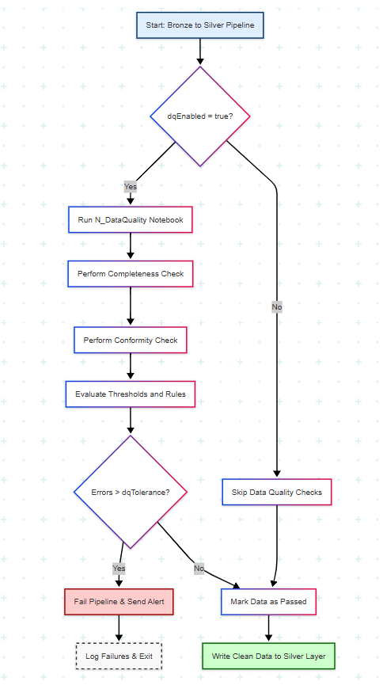
High level flow of the N_DataQuality notebook in the Silver Layer
Data Quality errors are logged in the Lakehouse table ‘FLH_Silver.mgmt.SilverDataQualityResults’.

Data Security

Identity and Access Management
Microsoft Fabric integrates with Microsoft Entra ID (formerly Azure Active Directory) to manage identity and access across its services. Access control is centralised, allowing administrators to enforce organisation-wide security policies:
- Users sign in using their Entra ID credentials, enabling single sign-on (SSO) across Fabric and other Microsoft 365 services.
- Role-based access control (RBAC) defines permissions at various levels (workspace, item, data).
- Conditional access policies (e.g., MFA, IP restrictions) are enforced via Entra ID settings.

Access Control by Workspace Role
Within Microsoft Fabric, granular access control is applied through workspace roles (Admin, Member, Contributor, Viewer). These roles determine who can view, edit, or manage content such as datasets, notebooks, reports, and pipelines:
- Permissions cascade from workspaces to their contents but can be overridden per item.
- Access logs are available through Microsoft Purview and Microsoft 365 compliance tools for auditing and compliance tracking.

Service Principals
Service principals and managed identities are supported for automated access scenarios. This enables secure integration with pipelines, dataflows, and external systems without embedding credentials:
- These identities can be assigned specific roles and limited scopes to minimize exposure.
- Integration with Microsoft Defender for Cloud provides ongoing identity risk monitoring.

EntraID (AAD) Security Groups for Fabric access

Security Groups
To enforce Role-Based Access Control (RBAC) across Microsoft Fabric environments, dedicated AAD security groups have been defined for both Non-Production and Production workspaces.
These groups govern workspace-level permissions aligned with Microsoft Fabric roles (Admin, Contributor, Member, Viewer) and are used in conjunction with Entra ID access policies.
Below is a table showing EntraID security group definitions.
Fabric Environment | Fabric Role | EntraID Group Name | Description
Non-Prod | Admin | G-SE-AAD-BOS-Fabric-NonProd-Admins | Full access to all workspaces, settings, deployment & management in Non-Prod
Non-Prod | Contributor | G-SE-AAD-BOS-Fabric-NonProd-Contributors | Create and manage content like datasets, notebooks, and pipelines
Non-Prod | Member | G-SE-AAD-BOS-Fabric-NonProd-Members | Can view, edit, and collaborate, but not manage workspace settings
Non-Prod | Reader | G-SE-AAD-BOS-Fabric-NonProd-Readers | View-only access to Fabric workspaces and content
Prod | Admin | G-SE-AAD-BOS-Fabric-Prod-Admins | Full control in production environment (restricted to platform owners)
Prod | Contributor | G-SE-AAD-BOS-Fabric-Prod-Contributors | Limited content creation, usually for power users or automation pipelines
Prod | Member | G-SE-AAD-BOS-Fabric-Prod-Members | View/edit capabilities, usually for business users and analysts
Prod | Reader | G-SE-AAD-BOS-Fabric-Prod-Readers | Read-only access to certified production reports and datasets

Access matrix
The above Security groups map to the below Fabric roles as shown in the access matrix below.
Role | Description | Non-Prod Access Level | Prod Access Level
Admin | Manage capacity, permissions, and workspace configuration | Full | Full (restricted)
Contributor | Create/edit pipelines, lakehouses, warehouses, reports | Full | Limited/Scoped
Member | Collaborate on content (edit notebooks, models, etc.) | Full | Scoped
Reader | View dashboards, datasets, reports | Read-only | Read-only

Data Access / Semantic Layer
Data access is primarily delivered through semantic models generated from the Gold layer, which is structured using the dimensional modelling approach. These models are exposed through Fabric’s built-in Power BI integration, allowing users to query, visualise, and explore data directly from curated datasets.
Each dataset or data warehouse in Fabric can auto-generate a default semantic model. For more tailored reporting, custom semantic models are built within Power BI Desktop and deployed back to Fabric. These models define calculated measures, KPIs, hierarchies, and relationships to support business-friendly navigation and slicing.
Security is enforced at the semantic layer using object-level security and can be extended to row-level security (RLS). Roles can be defined and extended to restrict access to subsets of data (e.g., by region or department), with rules applied within Power BI or directly via Entra ID group mappings.
Semantic Layer Highlights:
- Default models: Auto-generated from Fabric Data Warehouse objects
- Custom models: Built for specific use cases using Power BI Desktop
- Object-level security: Scoped access via roles for database objected
- Row-level security: Scoped access via roles and group-based filters

Delta Table Time Travel
Delta time travel allows you to query data from a previous state by referencing a specific timestamp or version. This capability enables access to historical data for auditing, debugging, or recovery scenarios.
Time travel in Delta tables leverages the transaction log to reconstruct the state of the data at a given point in time. Users can query previous versions of a Delta table by specifying a version number or a timestamp, making it easy to audit historical data, roll back unintended changes, or reproduce experimental results. This functionality assists data integrity, traceability, and compliance.
PySpark example:
df = spark.read \
.format("delta") \
.option("timestampAsOf", "2019-01-01") \
.load("/path/to/my/table")

Spark SQL example:
SELECT count(*) FROM my_table TIMESTAMP AS OF "2019-01-01"
SELECT count(*) FROM my_table TIMESTAMP AS OF date_sub(current_date(), 1)
SELECT count(*) FROM my_table TIMESTAMP AS OF "2019-01-01 01:30:00.000"

For more details, please see Understand storage for Direct Lake semantic models - Microsoft Fabric.

Scalability and Performance
The platform is designed for horizontal scalability, using parallelized ingestion pipelines, Delta Lake formats, and Spark-based transformations. The metadata-driven pipeline orchestration allows tuning concurrency levels and batch sizes to handle large data volumes efficiently.
Performance is optimised through partitioning strategies at the bronze and silver layers—typically by date, region, or domain keys—ensuring efficient query access and reduced compute time. Data is stored in Delta format with built-in indexing and compression for fast reads and writes.
Spark notebooks use Fabric capacity (F4 SKU), and their execution is distributed for performance. Aggregation in the gold layer (fact tables, pre-joins) further improves speed for report consumption.
Performance Enablers:
- Metadata-driven pipeline batches and concurrency settings
- Delta format with partitioning for scalable storage
- Spark notebooks with distributed computing

Data Consistency and Validation

Data validation against the previous state solution
The validation process ensures the integrity of the data migrated to the non-production environment by comparing it against the previously established state. This comparison focuses on critical business tables and evaluates row-level consistency, data completeness, and column-level accuracy. The goal is to confirm that no data loss, corruption, or unintended transformation has occurred during migration.
The notebook performs table-by-table comparisons between the legacy data store and the new environment. Using join operations and aggregations, it identifies mismatches in row counts, missing keys, and non-matching records. It also includes checks on nullability, data type alignment, and sample record comparisons for further assurance.
Summary results of the comparisons are logged for each dataset. Where discrepancies were identified, they are highlighted for investigation by persisting the data to Fabric.
This methodical validation process provides confidence in the fidelity of the data migration and ensures alignment with expected business outcomes.
Details of the PySpark Notebook used are shown below:
Notebook | Purpose
N_Data_Validation | Compares legacy and migrated datasets in non-prod. Highlights data mismatches and validates schema alignment.

Data validation across Non-Prod and Prod environments
The validation script systematically compares datasets between the Non-Prod and Prod environments. The row counts and column definitions are verified for each table across both environments. Row-level validation is performed using hash-based comparisons.
Key metadata is retrieved dynamically, and a filtering mechanism excludes specific layers and schemas irrelevant to the comparison scope. The script computes mismatches in both directions—missing in Prod and missing in Non-Prod—to ensure completeness and bidirectional integrity. Any differences are logged clearly to assist in remediation and finally persisted to Microsoft Fabric to assist in tracking and correcting issues.
Validation results are consolidated into a structured format that captures source and target metadata, row count mismatches, schema alignment flags, and timestamps. This provides a reliable audit trail and supports accountability in deployment assurance. See the details of the notebook used below for more details.
Notebook | Purpose
N_Prod_Deployment_Data_Validation | Validates data consistency and schema alignment between Non-Prod and Prod environments. Identifies and logs row-level and schema-level mismatches across datasets.

Observability and Monitoring
Observability is built into the platform using Fabric's built-in alerting and logging features. A single Activator rule, driven by the pipeline monitoring solution, detects master data pipelines that stop completing successfully and raises a Teams notification for prompt resolution (Section 3.7).
Observability has since been extended by the dedicated pipeline monitoring solution documented in Section 3.8. That solution collects Fabric job instance, activity run and pipeline definition history into the meta schema of FLH_Bronze once daily, exposes it through the pipeline_monitoring semantic model and report, and publishes the master-pipeline status feed that drives the alert. It provides the pipeline-level success rate, failure trend and failure-investigation views that this section previously described as capable of being built.

Ingestion status is tracked using BatchId, StartTime, EndTime, and Status control tables. Pipelines write to these logs on execution, which makes it easy to monitor performance trends and failure patterns. Notebooks also log transformation steps and data quality metrics for audit.
Monitoring is extended via centralized logging, where custom views can be built in Power BI to monitor ingestion KPIs like volume, freshness, success rate, and duration.
Monitoring components include:
- Activator rule alerting on master pipeline status changes (Section 3.7)

- Control table logs for ingestion lifecycle tracking
- Power BI dashboards for observability metrics
The flow below details how a master pipeline failure is detected and alerted: the monitoring notebook collects run history and publishes the master-pipeline status, the eventstream carries that status to the Activator, and the Activator notifies the support team, who investigate using the pipeline monitoring report.

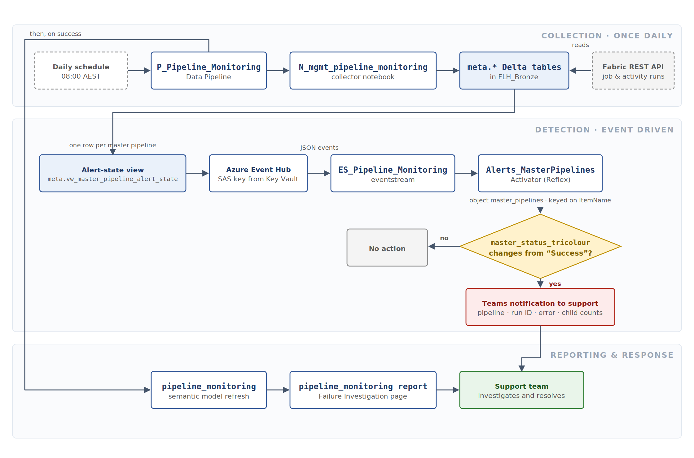

High level flow showing pipeline monitoring, failure detection and alerting

To access Monitor, please see Fabric Monitor – DCCEEW:
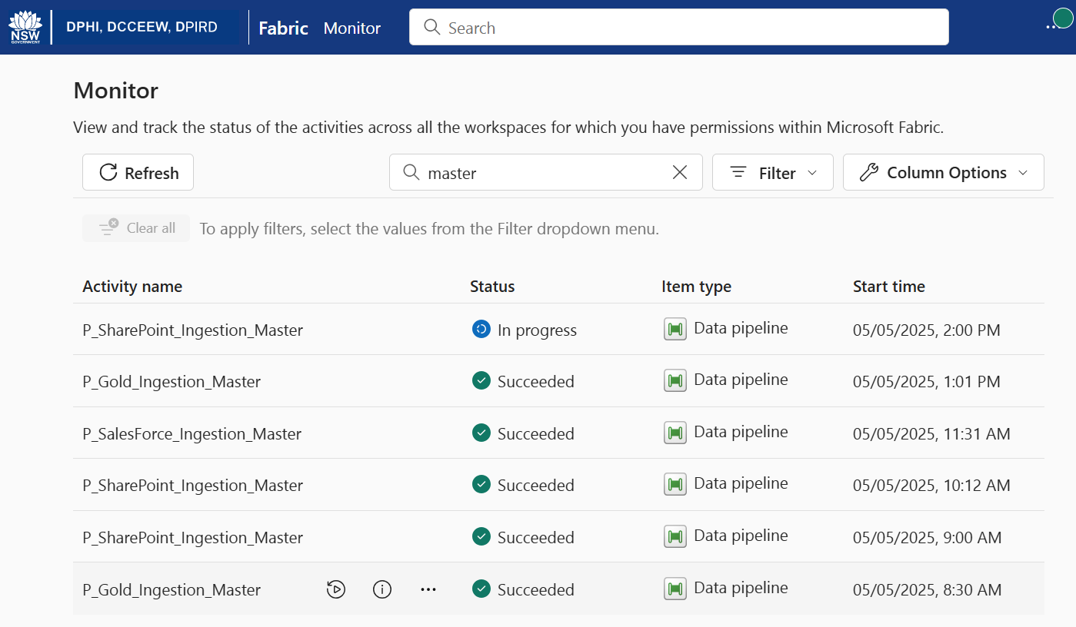

Cost Management
Cost is managed by optimising resource usage, scheduling, and storage tiering. Fabric capacity (F4 SKU) is shared across environments, and workloads are isolated between Dev and Prod using Fabric workspace separation. Schedules are staggered to avoid peak-time contention.
Efficient use of computing is achieved by tuning batch sizes and concurrency limits and avoiding over-processing through delta-based ingestion. Storage costs are optimized by storing raw and intermediate data in Delta format and using compression (Snappy, Gzip).
Deployment automation minimises manual effort and errors where possible, reducing overhead. The platform allows proactive tuning of dataflows, pipelines and notebooks for performance-cost balance.
Cost Control Measures:
- Shared capacity use with workload isolation
- Optimised batch processing and partitioning
- Storage compression and Delta formats
Finally, note that costs for the Fabric Capacity can be viewed and monitored via Azure Portal (Fabric Capacity bosdatanonprod).

Data Archival and Retention
Data retention across the platform is managed according to the characteristics and purpose of each data layer. Layers within the platform containing curated and business-ready data are generally retained indefinitely to support reporting, audits, and historical analysis.
Retention workflows can be defined using Fabric Pipelines that evaluate data based on IngestionTimestamp or similar metadata fields. These pipelines can be configured to delete or move data that exceeds the specified age threshold, supporting time-based lifecycle policies.

Additionally, a data retention policy can be set up and enabled as needed, offering flexibility to control data removal from tables or materialized views. A policy can be set up to automatically remove data from tables that continuously receive new records, such as diagnostics events, which may lose relevance after a certain period for example.
An appropriate policy can be set up and enabled/disabled as required. Please see Change data policies – Data Retention Policies - Microsoft Fabric.

Interoperability and Integration
The Microsoft Fabric platform is inherently designed for seamless interoperability, enabling the integration of data from diverse sources, including RESTful APIs, relational databases, and file-based systems. Fabric Pipelines provide robust support for these sources through a comprehensive set of native connectors and REST and SQL-based ingestion mechanisms.
Data transformation is performed using both PySpark notebooks and T-SQL scripts, offering flexibility to implement complex integration logic tailored to specific business needs. Ingested data from various domains is consolidated within the Lakehouse architecture, ensuring consistent presentation through standardised semantic models.
Metadata-driven mappings facilitate clear and governed source-to-target data flows across all ingestion types, supporting both structured and semi-structured data integration.
External analytics and reporting tools—including Microsoft Power BI, Excel, and third-party platforms—can connect directly to Fabric via ODBC, REST APIs, or live connections to semantic models, enabling real-time access to curated, business-ready data.
Key Integration Features:
- Rich library of native connectors for APIs, databases, and file systems
- Unified transformation capabilities using PySpark and T-SQL
- Metadata-driven data mapping and control
- Direct interoperability with BI tools and external systems via ODBC, REST, and live semantic model connections

Use-cases
Below are the current use-cases that utilise the patterns documented in Section 3 to achieve a use-case. The platform can support any number of use cases that use the documented patterns.
If a new use case is onboarded to the Fabric Data platform, its documentation can be added here.

BioNet API Ingestion
This section refers to the BioNet API Ingestion developed for BioNet data. It follows a standardised pattern for API data ingestion; however, due to the significant variability in API interfaces and specifications, some custom Fabric Data Factory pipelines have been implemented within the Bronze layer to accommodate these differences.

Ingestion

Copy data activity details

Source
Source Attribute | Details
Type | API via Native Fabric Data Factory connectors
Format | JSON data unpacked to form tabular data from the objects
Configuration | Uses HTTP GET selecting fields and filtering records for extraction.
Compression | Supported for output files
Authentication | Anonymous (Public API)

Sink
Sink Attribute | Details
Type | Fabric Data Warehouse  Fabric Lakehouse  Other: Azure SQL Database, Azure Synapse Analytics, or Data Warehouses.
Format | Delta Lake  Other: Tabular formats (e.g., Tables) or Parquet for analytical purposes.
Partitioning | Based on timestamp, region, or object type for optimized queries.
Compression | Optional compression (e.g., Snappy or Gzip) for analytical workloads.
Configuration | Schema mapping between ePlanning fields and target columns in the sink.

Pipeline parameters
Name | Type | Example Value | Purpose
objectApiName | String | "Application" | Specifies the API object to extract data from (dynamic URL path).
ObjectLoadType | String | "DeltaLoad" or "FullLoad" | Defines whether a full load or delta (incremental) load is performed.
watermarkColumnStartValue | String | "2024-01-01T00:00:00Z" | Starting point for delta load filtering (e.g., updated records since a date).
windowStart | String | "2025-03-21T00:00:00Z" | Timestamp for the batch process (used for BatchId creation).
watermarkColumnName | String | "LastModifiedDate" | (Variable) Name of the column used for delta loads
totalPages | Integer | 10 | (Variable) Total number of pages returned by the API.
currentPage | Integer | 1 | (Variable) Tracks the current page being processed.
tempPage | Integer | 2 | (Variable) Temporary holder for next page calculation.
Temp | String | (not explicitly shown; placeholder string) | (Variable) Temporary holder to assist next page calculation.

Master pipeline
Master pipeline name | Description
  P_ BioNet_Ingestion_Master
  Orchestrates the end-to-end ingestion process for BioNet data source.

Module pipeline
Module Name | Description
L_ BioNet _MetadataDrivenCopyTask_TopLevel | Native Fabric metadata driven copy activity pipeline top level which divides objects into batches and sends to the middle level module pipeline below
L_ BioNet _MetadataDrivenCopyTask_MiddleLevel | Native Fabric metadata driven copy activity pipeline middle level which routes batches of objects according to pipeline concurrency to be further ingestion
L_ BioNet _MetadataDrivenCopyTask_BottomLevel | Native Fabric metadata driven copy activity pipeline bottom level copies objects from BioNet API via native connectors
L_ BioNet _Load_From_API_Endpoint | Native Fabric metadata driven copy activity pipeline bottom level copies accepts an object and manages the ingestion including watermarks (if applicable)
L_MergeBronzeToSilver | Runs a Fabric notebook to write Delta Tables in Silver

e-Planning API Ingestion
This section refers to the ePlanning API Ingestion developed for ePlanning data.
It follows a standardised pattern for API data ingestion; however, due to the significant variability in API interfaces and specifications, some custom Fabric Data Factory pipelines have been implemented within the Bronze layer to accommodate these differences.

Ingestion

Copy data activity details

Source
Source Attribute | Details
Type | API via Native Fabric Data Factory connectors
Format | JSON data unpacked to form tabular data from the objects
Configuration | Uses HTTP GET selecting fields and filtering records for extraction.
Compression | Supported for output files
Authentication | Anonymous (Public API)

Sink
Sink Attribute | Details
Type | Fabric Data Warehouse  Fabric Lakehouse  Other: Azure SQL Database, Azure Synapse Analytics, or Data Warehouses.
Format | Delta Lake  Other: Tabular formats (e.g., Tables) or Parquet for analytical purposes.
Partitioning | Based on timestamp, region, or object type for optimized queries.
Compression | Optional compression (e.g., Snappy or Gzip) for analytical workloads.
Configuration | Schema mapping between ePlanning fields and target columns in the sink.

Pipeline parameters
Name | Type | Example Value | Purpose
objectApiName | String | "Application" | Specifies the API object to extract data from (dynamic URL path).
ObjectLoadType | String | "DeltaLoad" or "FullLoad" | Defines whether a full load or delta (incremental) load is performed.
watermarkColumnStartValue | String | "2024-01-01T00:00:00Z" | Starting point for delta load filtering (e.g., updated records since a date).
windowStart | String | "2025-03-21T00:00:00Z" | Timestamp for the batch process (used for BatchId creation).
watermarkColumnName | String | "LastModifiedDate" | (Variable) Name of the column used for delta loads
totalPages | Integer | 10 | (Variable) Total number of pages returned by the API.
currentPage | Integer | 1 | (Variable) Tracks the current page being processed.
tempPage | Integer | 2 | (Variable) Temporary holder for next page calculation.
Temp | String | (not explicitly shown; placeholder string) | (Variable) Temporary holder to assist next page calculation.

Master pipeline
Master pipeline name | Description
  P_ ePlanning_Ingestion_Master
  Orchestrates the end-to-end ingestion process for ePlanning data source.

Module pipeline
Module Name | Description
L_ePlanning_MetadataDrivenCopyTask_TopLevel | Native Fabric metadata driven copy activity pipeline top level which divides objects into batches and sends to the middle level module pipeline below
L_ePlanning _MetadataDrivenCopyTask_MiddleLevel | Native Fabric metadata driven copy activity pipeline middle level which routes batches of objects according to pipeline concurrency to be further ingestion
L_ePlanning _MetadataDrivenCopyTask_BottomLevel | Native Fabric metadata driven copy activity pipeline bottom level copies objects from ePlanning API via native connectors
L_ePlanning_Load_From_API_Endpoint | Native Fabric metadata driven copy activity pipeline bottom level copies accepts an object and manages the ingestion including watermarks (if applicable)
L_MergeBronzeToSilver | Runs a Fabric notebook to write Delta Tables in Silver

Salesforce API Ingestion
This section outlines the Salesforce API ingestion process explicitly designed for structured Salesforce data. It leverages the standard pattern for structured data ingestion, with Fabric Data Factory copy activities enabling flexible extraction methods tailored to Salesforce's API capabilities.
These include:
- Bulk Query Mode: Efficient for large datasets, leveraging Salesforce's Bulk API for optimized data extraction.
- SOQL Queries: Allows extraction of specific fields or records using Salesforce Object Query Language for more granular control.
- Change Data Capture (CDC): Captures real-time changes (inserts, updates, deletes) to Salesforce data for incremental data ingestion.
- Object-Based Extraction: Ingests entire Salesforce objects (e.g., Accounts, Contacts, Opportunities) for comprehensive data loading.
- Filtering Options: Use of filters to target specific datasets, reducing unnecessary data transfer.
- Hierarchical Data Mapping: Extracts and transforms nested relationships, such as parent-child object structures, into usable formats.

Ingestion

Copy data activity details

Source
Source Attribute | Details
Type | Salesforce (via Bulk API Query Mode).
Format | Tabular data in CSV or JSON format extracted through Bulk API 2.0.
Configuration | Uses SOQL queries for selecting fields and filtering records for extraction.
Compression | Supported for output files from Bulk API 2.0 (e.g., Gzip).
Authentication | OAuth 2.0 for secure access to Salesforce.

Sink
Sink Attribute | Details
Type | Fabric Data Warehouse  Fabric Lakehouse  Other: Azure SQL Database, Azure Synapse Analytics, or Data Warehouses.
Format | Delta Lake  Other: Tabular formats (e.g., Tables) or Parquet for analytical purposes.
Partitioning | Based on timestamp, region, or object type for optimized queries.
Compression | Optional compression (e.g., Snappy or Gzip) for analytical workloads.
Configuration | Schema mapping between Salesforce fields and target columns in the sink.

Pipeline parameters
Name | Type | Example Value | Purpose
SalesforceObject | String | "Account" | Specifies the Salesforce object to extract data from (e.g., Account, Contact).
SOQLQuery (OPTIONAL) | String | "SELECT Id, Name FROM Account WHERE LastModifiedDate > 2023-01-01T00:00:00Z" | Custom SOQL query for targeted extraction.
BatchSize | Integer | 50000 | Sets the batch size for Bulk API operations.
RetryCount | Integer | 3 | Specifies retry attempts in case of transient errors.
SinkPath | String | "/processed/salesforce/" | Defines the sink location for ingested Salesforce data.
SchemaMapping | String (JSON) | "{Salesforce_Field: Target_Column}" | Maps Salesforce fields to sink columns.

Master pipeline
Master pipeline name | Description
  P_ Salesforce_Ingestion_Master
  Orchestrates the end-to-end ingestion process for Salesforce data source.

Module pipeline
Module Name | Description
L_SF_MetadataDrivenCopyTask_TopLevel | Native Fabric metadata driven copy activity pipeline top level which divides objects into batches and sends to the middle level module pipeline below
L_SF_MetadataDrivenCopyTask_MiddleLevel | Native Fabric metadata driven copy activity pipeline middle level which routes batches of objects according to pipeline concurrency to be further ingestion
L_SF_MetadataDrivenCopyTask_BottomLevel | Native Fabric metadata driven copy activity pipeline bottom level copies objects from salesforce via Salesforce Bulk API 2.0
L_MergeBronzeToSilver | Runs a Fabric notebook to write Delta Tables in Silver

Transformation

Spark notebooks
        - Main
Spark Notebook | Purpose
N_BronzeToSilver | Fabric notebook to write Delta Tables in Silver over Tabular Data Streams

GOULBDB On-Premises SQL Ingestion
This section describes the GOULDB ingestion process developed for on-premises SQL data sources. It follows the structured data ingestion pattern, using Fabric Data Factory copy activities to extract data through Power BI on-premises gateways, which were provisioned specifically to enable this connectivity.

Ingestion

Copy data activity details

Source
Source Attribute | Details
Type | GOULBDB On-premises SQL Server
Format | Tabular data
Configuration | It uses T-SQL-based queries in pipelines to select fields and filter records for extraction.
Compression | Supported for output files (e.g., Gzip).
Authentication | Via the upstream Power BI Gateway

Sink
Sink Attribute | Details
Type | Fabric Data Warehouse  Fabric Lakehouse  Other: Azure SQL Database, Azure Synapse Analytics, or Data Warehouses.
Format | Delta Lake  Other: Tabular formats (e.g., Tables) or Parquet for analytical purposes.
Partitioning | Based on timestamp, region, or object type for optimized queries.
Compression | Optional compression (e.g., Snappy or Gzip) for analytical workloads.
Configuration | Schema mapping between Salesforce fields and target columns in the sink.

Pipeline parameters
Name | Type | Example Value | Purpose
Object | String | "BiodiversityConservationalEntity" | Specifies the GOULBDB object to extract data from
WatermarkSQLQuery (OPTIONAL) | String | "SELECT Id, Name FROM BiodiversityConservationalEntity WHERE LastModifiedDate > 2023-01-01T00:00:00Z" | Custom SQL query for targeted extraction.
BatchSize | Integer | 50000 | Sets the batch size for operations.
RetryCount | Integer | 3 | Specifies retry attempts in case of transient errors.
SinkPath | String | "FLH_Bronze.BiodiversityCalDBBAMC. BiodiversityConservationalEntity " | Defines the sink table for ingested data.
SchemaMapping (OPTIONAL) | String (JSON) | "{_Field: Target_Column}" | Maps fields to sink columns in bronze.

Master pipeline
Master pipeline name | Description
  P_ GOULBDB_Ingestion_Master
  Orchestrates the end-to-end ingestion process for GOULBDB data source.

Module pipeline
Module Name | Description
L_ GOULBDB _MetadataDrivenCopyTask_TopLevel | Native Fabric metadata driven copy activity pipeline top level which divides objects into batches and sends to the middle level module pipeline below
L_ GOULBDB _MetadataDrivenCopyTask_MiddleLevel | Native Fabric metadata driven copy activity pipeline middle level which routes batches of objects according to pipeline concurrency to be further ingestion
L_ GOULBDB _MetadataDrivenCopyTask_BottomLevel | Native Fabric metadata driven copy activity pipeline bottom level copies objects from goulbdb
L_MergeBronzeToSilver | Runs a Fabric notebook to write Delta Tables in Silver

Transformation

Spark notebooks
        - Main
Spark Notebook | Purpose
N_BronzeToSilver | Fabric notebook to write Delta Tables in Silver over Tabular Data Streams

SharePoint Ingestion
This section refers to the SharePoint ingestion developed for SharePoint Site/Excel data.
It utilises a dataflow pattern for structured data ingestion.

Ingestion

Copy data activity details

Source
Source Attribute | Details
Type | SharePoint Excel
Format | Tabular data
Configuration | Uses Data flow v2 selecting fields and transformations for extraction with Full load / overwrite
Compression | Supported for output files (e.g., Gzip).
Authentication | Via Service Account

Sink
Sink Attribute | Details
Type | Fabric Data Warehouse  Fabric Lakehouse  Other: Azure SQL Database, Azure Synapse Analytics, or Data Warehouses.
Format | Delta Lake  Other: Tabular formats (e.g., Tables) or Parquet for analytical purposes.
Partitioning | Based on timestamp, region, or object type for optimized queries.
Compression | Optional compression (e.g., Snappy or Gzip) for analytical workloads.
Configuration | Schema mapping between fields and target columns in the sink.

Pipeline parameters
Name | Type | Example Value | Purpose
Object | String | "BiodiversityEntity" | Specifies the object to extract data from
PowerQuery Transformations | String | PowerQuery Advanced Editor inputs and outputs | Defines the transformations in Power Query format.

Master pipeline
Master pipeline name | Description
  P_ SharePoint_Ingestion_Master
  Orchestrates the end-to-end ingestion process for SharePoint data source.

Module pipeline
Module Name | Description
L_ Sharepoint _MetadataDrivenCopyTask_TopLevel | Native Fabric metadata driven copy activity pipeline top level which divides objects into batches and sends to the middle level module pipeline below
L_ Sharepoint _MetadataDrivenCopyTask_MiddleLevel | Native Fabric metadata driven copy activity pipeline middle level which routes batches of objects according to pipeline concurrency to be further ingestion
L_ Sharepoint _MetadataDrivenCopyTask_BottomLevel | Native Fabric metadata driven copy activity pipeline bottom level copies objects from SharePoint
L_MergeBronzeToSilver | Runs a Fabric notebook to write Delta Tables in Silver

Transformation

Spark notebooks
        - Main
Spark Notebook | Purpose
N_BronzeToSilver | Fabric notebook to write Delta Tables in Silver over Tabular Data Streams

Planning API Ingestion
This section documents the ingestion of planning application data from the NSW Planning API into the Microsoft Fabric platform. The Planning API ingestion has been implemented as part of BOS - Data and Traceability Phase 2, extending the existing semi‑structured API ingestion framework.
The Planning API ingestion is implemented as a dedicated ingestion stream and operates independently of the legacy e‑Planning API ingestion described in Section 5.2.

Ingestion

Copy data activity details

Source
Source Attribute | Details
Type | API via Native Fabric Data Factory connectors
Format | JSON
Configuration | Uses HTTP GET requests with pagination support, selecting fields and filtering records for extraction.
Compression | Supported for output files
Authentication | API Key and OAuth 2.0 client credentials

Sink
Sink Attribute | Details
Type | Fabric Lakehouse (Bronze and Silver) / Fabric Data Warehouse (Gold)
Format | Delta Lake  Other: Tabular formats (e.g., Tables) or Parquet for analytical purposes.
Partitioning | Based on timestamp, region, or object type for optimized queries.
Compression | Optional compression (e.g., Snappy or Gzip) for analytical workloads.
Configuration | Schema mapping between Planning API fields and target columns in the sink.

Pipeline parameters
Name | Type | Example Value | Purpose
objectApiName | String | "OnlineDA" | Identifies the Planning API endpoint / object being ingested
ObjectLoadType | String | "DeltaLoad" or "FullLoad" | Defines whether the object is ingested incrementally or via full load
watermarkColumnName | String | "lastModifiedDate" | Column used to identify incremental changes where supported
watermarkColumnStartValue | String | "2024-01-01T00:00:00Z" | Initial watermark value for delta loads
windowStart | String | "2026-04-15T07:00:00Z" | Trigger timestamp used to derive BatchId
totalPages | Integer | 25 | Total number of pages returned by the API
currentPage | Integer | 1 | Tracks current API page being processed

Master pipeline
Master pipeline name | Description
P_Planning_Ingestion_Master | Orchestrates the end-to-end ingestion of Planning API data, including Bronze ingestion, Silver transformation, and Gold loading

Module pipeline
Module Name | Description
P_Planning_Ingestion_TopLevel | Controls batching and parallelisation of Planning API ingestion objects
L_PLANIngestion_MiddleLevel | Divides ingestion batches into parallel execution groups
L_PLANIngestion_BottomLevel | Executes API calls per object, handles pagination, and writes raw JSON to Bronze
L_MergeBronzeToSilver | Runs Spark notebooks to parse, transform, and load Planning data into Silver
L_MergeSilverToGold | Executes T-SQL notebooks and stored procedures to load curated Planning data into Gold

Transformation

Spark notebooks
        - Main
Spark Notebook | Purpose
N_BronzeToSilver | Fabric notebook to write Delta Tables in Silver over Tabular Data Streams

Pipeline Schedules
Master pipeline name | Schedule
P_GOULBDB_Ingestion_Master | Daily at 07:00 AM
P_SalesForce_Ingestion_Master | Daily at 11:30 AM
P_SharePoint_Ingestion_Master | Daily at 09:00 AM, 02:00 PM
P_Gold_Ingestion_Master | Daily at 08:30 AM, 01:00 PM
P_Metadata_Ingestion_Master | Off (On-demand)
P_ePlanning_Ingestion_Master | Daily at 07:30 AM
P_BioNet_Ingestion_Master | Daily at 04:45 AM
P_Planning_Ingestion_Master | Daily at 07:05 AM

Continuous Integration & Deployment (CI/CD)

Introduction
This section outlines our recommended process for implementing Microsoft Fabric CI/CD DevOps, divided into two main stages: Continuous Integration (CI) and Continuous Deployment (CD). Various options available for each stage will be discussed, followed by our best recommendations to ensure an efficient implementation for projects.

Continuous Integration (CI) Stage
The Fabric workspace is a shared environment that accesses live items. Any changes made directly in the workspace override and affect all other users. Therefore, Git best practice is for developers to work in isolation outside of the shared workspaces.
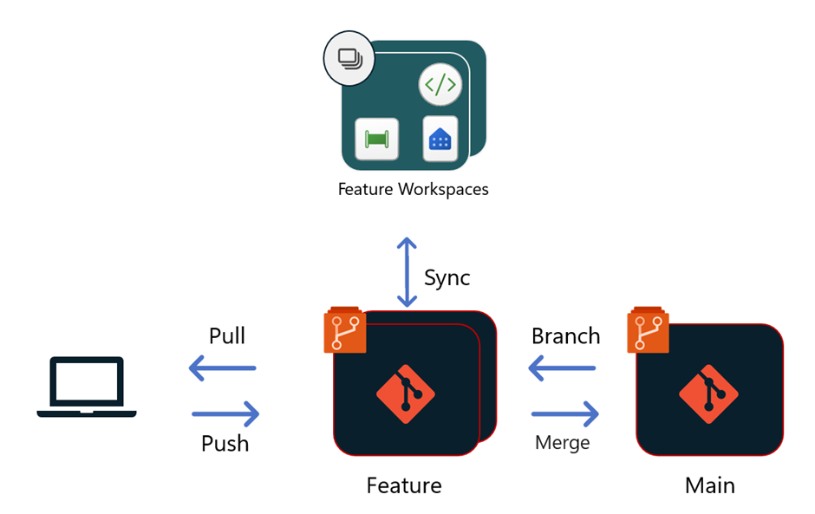

Workflow for CI
For a developer who works on the web, the flow would be as follows:
- Navigate to the Dev workspace. Select Branch out to a new workspace from the Source control menu's Branches tab.
- Specify the names of the branch and workspace. The new branch was created based on the branch connected to the current workspace.
- Select Branch out. Fabric creates the new workspace and branch. You're automatically taken to the new workspace. The workspace syncs with your feature branch and becomes an isolated environment in which to work, as illustrated. You can now work in this new isolated environment. The sync might take a few minutes.
Feature branch naming standard: feature-{User Initials}-{Purpose}
Primary Integration branches: Prod, Dev, UAT
- Save and commit to the Feature branch
- When ready, create a PR to the dev branch. The review and merge processes are done through Azure Repos based on the configuration your team defined for that repo.
- Once the PR review and merge to Dev are complete, a new commit is created to the UAT & Prod branch. This commit prompts the user to update the content in the Dev team's workspace with the merged changes.
- Download the Dataflow PQT format files from the repo, create a dataflow for each file, and import each PQT file individually. Once imported, set the connection credentials.

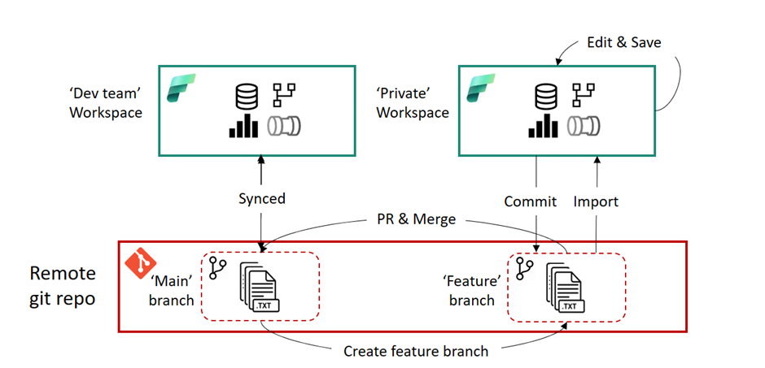

Best Recommendation for CI
Developers should work in isolation outside of shared workspaces to avoid affecting other users. The CI workflow involves branching out to a new workspace, working in isolation, and syncing with the feature branch. When ready, changes are committed, and a pull request is created to merge into the Prod branch. The merged changes prompt an update in the Dev team's workspace.

Continuous Deployment (CD)
Continuous Deployment (CD) is the practice of automatically deploying every approved change to UAT environment and that passes the tests to a production environment. This ensures that the new features and fixes reach users as quickly as possible while maintaining high quality.
The release process starts once new updates are complete and the pull request (PR) merged into the team’s shared branch (such as Prod, Dev etc.). From this point, there are different options to build a release process in Fabric.

Git-based deployments – Our Recommendation
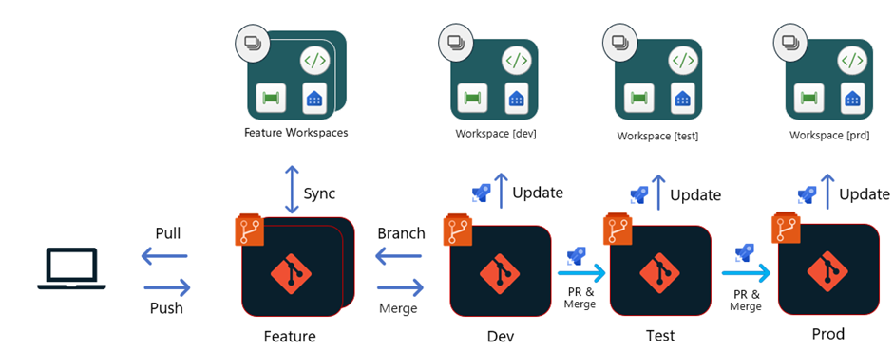
Once a PR to the Dev branch is approved and merged:
- Update the content of the Dev workspace
- A PR is then created for the UAT branch. The PR should include the same review and approval processes as any other in your team or organization
- Update the UAT workspace with branch contents, update the connections and parameters. Once the test criteria are met, a PR is created to the Prod branch
- After completing the PR, update the Prod workspace with branch contents, update the connections and parameters
Updating Primary workspaces with branch contents is done manually, as are any customisation steps required for updating connections or parameters.
While Fabric's latest updates introduce APIS for updating items, the technology is still evolving, and detailed guidance or support on effectively using these APIS is currently unavailable.
When to consider
- When you want to use your Git repo as the source of truth and the origin of all deployments.
- When your team follows a standard branching strategy, including multiple primary branches for Dev, Prod & UAT.
- Upload from the repo goes directly into the workspace

Git-based deployments using Build Environments
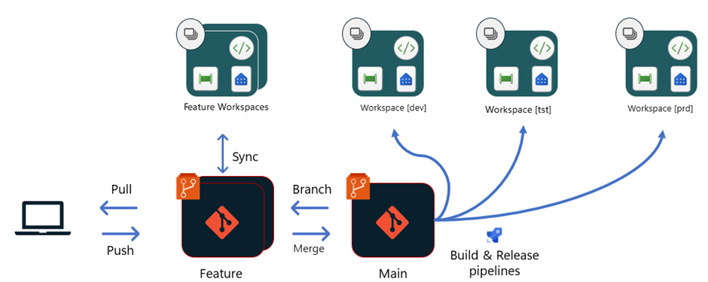
With this option, all deployments originate from the same branch of the Git repository (Prod). Each stage in the release pipeline has a dedicated build and Release pipeline.
When to consider
- When you want to use Git as your single source of truth and the origin of all deployments.
- When your team follows Trunk-based workflow as its branching strategy.

Deploy using Fabric deployment pipelines
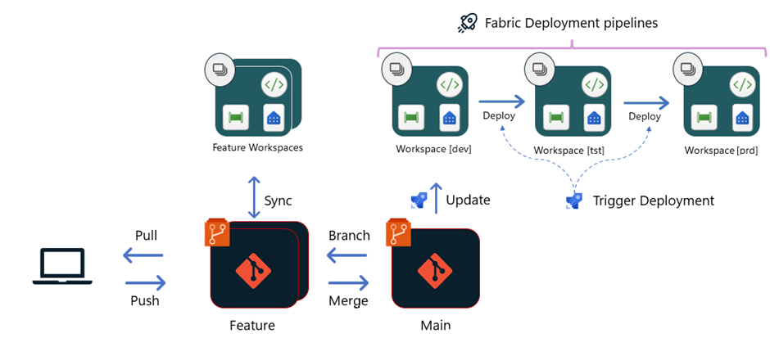
With this option, Git is connected only until the dev stage. From the dev stage, deployments happen directly between the workspaces of Dev/UAT/Prod, using Fabric deployment pipelines.

When to consider
- When you're using source control only for development purposes and prefer to deploy changes directly between stages of the release pipeline.
- When you want to use other functionalities of Fabric deployment pipelines, such as viewing changes in Fabric, deployment history etc.
- When sources and parameters are to be altered using Fabric deployment rules, but this has limitations as they are limited to certain Fabric items

Comparison of Deployment Methods

Feature | A. Git-based Deployments | B. Git-based Deployments using Build Environments | C. Deploy using Fabric Deployment Pipelines
Branching Strategy | Multiple primary branches (Dev, UAT, Prod) | Trunk-based workflow (single Prod branch) | No strict branching strategy
Source of Truth | Git repository | Git repository | Git for Dev; direct between workspaces for UAT/Prod
Pipeline Type | Manual PR creation and updates | Automated build and release pipelines | Fabric deployment pipelines
Customisation of Connections/Parameters | Manual customisation | Managed in pipelines | Deployment rules (limited functionality)
Automation Level | Manual for workspace updates | Automated through pipelines | Semi-automated via Fabric pipelines
Deployment History | Managed in Git | Managed in Git and pipeline logs | Tracked in Fabric deployment pipelines
Use Case | Standard branching workflows with manual intervention | Trunk-based workflows with full CI/CD automation | Simplified deployment with direct workspace interaction
Limitations | Manual steps for updating workspaces | Requires dedicated pipeline setup and maintenance | Limited to certain Fabric items for parameter updates

This table highlights the key differences, helping you choose the most suitable deployment method based on workflow and team requirements.
While Fabric Deployment Pipelines (Option C) is the target for its integrated features, it currently lacks support for parameter and connection updates and is not production-ready. Therefore, we recommend Option A, Git-based Deployment, as a reliable solution. This approach ensures stability, control, and alignment with Git workflows, enabling a smooth future transition to Option C once it matures.

Fabric Development Rules
- Whenever code is pushed to Dev, make sure to share all the involved connections with all the team members.
- Artifacts in the Git synced workspace should not be deleted manually. Instead, delete the related folders in the Git branch and sync the branch.
- Make sure to commit changes via the Workspace Interface, as clicking Save will not commit.

Power BI Reports Documentation
List of Power BI workspaces, semantic models, and dependent reports that have been moved to Fabric workspaces and connections.

Current State
The following workspaces are currently in use for Power BI reporting and dataflows sharing in the organization:

Production Workspaces:
  - DCEEW Bio Reforms
  - DCCEEW BOS and Planning Data Sharing (Used exclusively for dataflow sharing purposes; no reporting assets are maintained in this workspace)
  - DCCEEW BOS Credits Transaction

User Acceptance Testing (UAT) Workspace:
  - Biodiversity Offsets Scheme [UAT]

Semantic Models and Dataflows
As part of the transition process, the following semantic models and dataflows have had their connections updated to point to the Fabric Warehouse.

DCEEW Bio Reforms
  - Semantic Models:
    - Data Team Requests
    - ETL Failure Warning

  - Reports:
    - BCT_BOS Credit Transactions

  - Dataflows:
    - BioNet TECs (Data ingested in Fabric -> Gold layer schema BioNet)

DCCEEW BOS and Planning Data Sharing
This workspace is used for the sharing of planning data through dataflows and only contains dataflows.
  - Dataflows:
    - MP_Dataflow
    - Planning_Assessment_Data

DCCEEW BOS Credits Transaction
  - Semantic Models:
    - BAM Credit Transactions_Data Model
      - Credit Life Cycle-POC Paginated Report
      - BAM Credit Transactions_EOM_rep Report
      - BAM Credit Transactions_EOQ_rep Report
      - Credit Life Cycle-POC Report
      - Ecosystem Credit Life Cycle-BCS Report
      - Credit Life cycle-With Agreements Nos Report
    - BOS Credit Transactions Register Report - internal
    - BOS Credit Transactions Register Report – summary
  - Dataflows:
    - XL Sheets-BOS TAS team

Biodiversity Offsets Scheme [UAT]
  - Semantic Models:
    - E-Planning Data
    - DEV_Supply Demand and Transaction registers
    - End to End Life Cycle

Semantic Model Ownership
Note that if using the ‘Take over’ button to manage a semantic model:
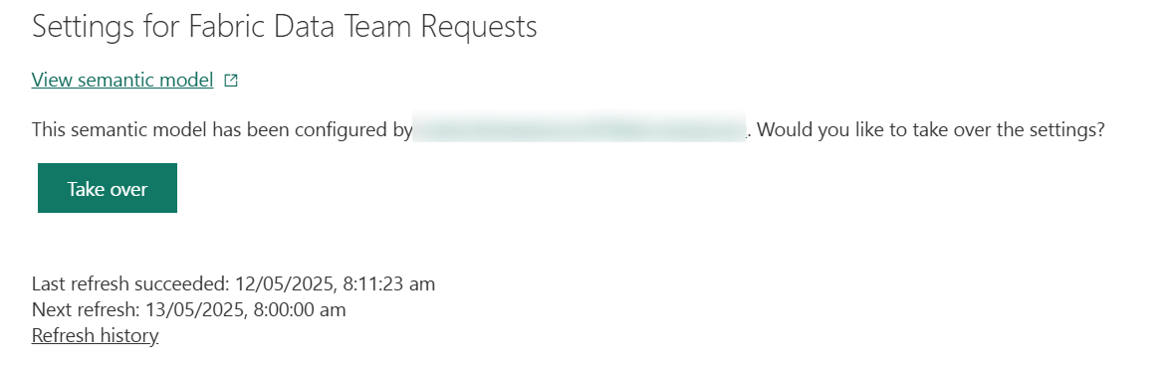
Ensure that the data sources are mapped to fdwh_gold which is Power BI’s connection to Fabric Gold:
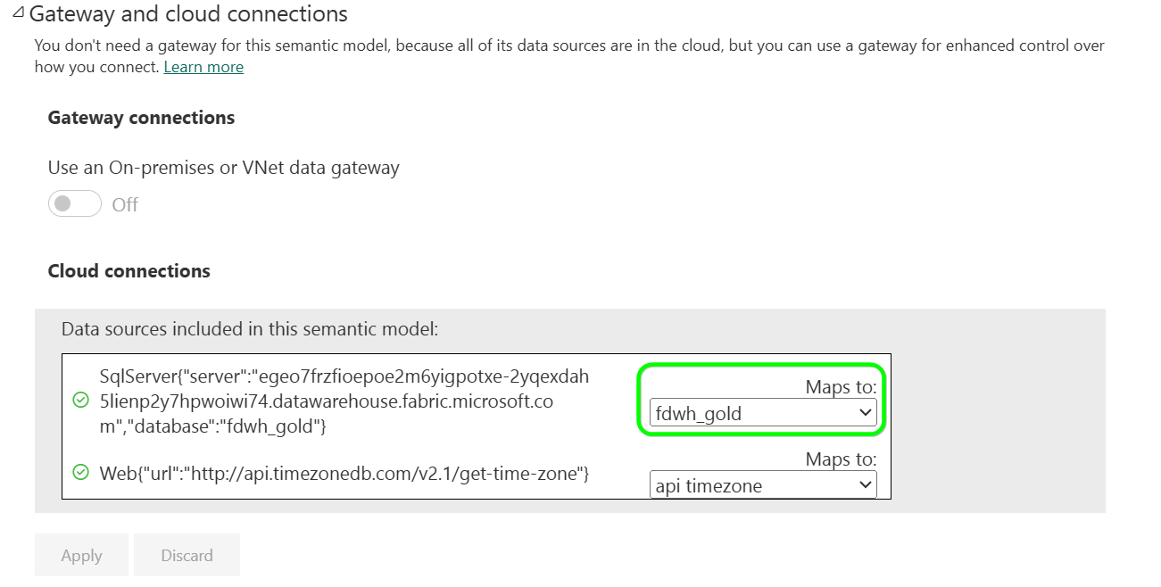

Fabric Migration – Completed Transition Summary
This section outlines the completed approach for transitioning Power BI workspaces, semantic models, and dataflows to the new Microsoft Fabric environment. The migration has been executed with a focus on structure, clarity, and minimal disruption to users.

Workspace Publishing Structure
To support a clean deployment process and safe validation, we implemented a dual-workspace publishing model:
A dedicated UAT Fabric workspace was created for each existing production workspace. Going forward, the UAT workspace should always be used to develop semantic models and reports while they are in their development phase.
Reports and semantic models were first published to UAT, tested, and then promoted to production.
In production, all Fabric-connected assets were placed in a clearly labelled subfolder:
➤ Fabric Reports
This allows users to temporarily access both legacy and Fabric versions of reports during the transition period.
Workspaces Involved:
- DCCEEW Bio Reforms
- DCCEEW BOS and Planning Data Sharing (used exclusively for sharing dataflows; no reporting assets maintained)
- DCCEEW BOS Credits Transaction

Semantic Models and dataflows Transition
All relevant semantic models have been successfully reconfigured to connect directly to the Fabric Warehouse. Dataflows have been fully ingested into the Fabric Warehouse, eliminating the need for direct connections to dataflows within the reports.
The following conventions were applied throughout the migration:
- Prefix Naming: All updated reports and models were prefixed with "Fabric" to distinguish them.
- Parameterisation: Server and database names were parameterised (Server, Gold Database) to streamline environment management.
- Batch Updates: Tabular Editor and Power BI REST API were used for batch connection changes when applicable.
- Schema Alignment: All schema mismatches (e.g., renamed tables or columns) were resolved during testing.

Testing and Validation
Reports were first published to the UAT workspace, where we:
Set up Gateways connections and refresh time on each semantic models
Validated report visuals and metrics against the legacy models
Resolved bugs, inconsistencies, and formatting issues
Verified that filters, slicers worked as expected
Following successful UAT, Fabric reports were then deployed to Production in a Fabric Reports folder.

Fabric Reports links

UAT Semantic Models
List of original semantic model links and their Fabric equivalent in UAT:
UAT semantic model (and report) Link | UAT Workspace | Original semantic model link | Original Workspace
Fabric BAM Credit Transactions_Data Model | DCCEEW BOS Credits Transactions Non-Prod | BAM Credit Transactions_Data Model | DCCEEW BOS Credits Transactions
Fabric End to End Life Cycle | DCCEEW Fabric Data Consolidation Project Non-Prod | End to End Life Cycle | Biodiversity Offsets Scheme [UAT]
Fabric E-Planning Data | DCCEEW Fabric Data Consolidation Project Non-Prod | E-Planning Data | Biodiversity Offsets Scheme [UAT]
Fabric DEV_Supply Demand and Transaction registers | DCCEEW Fabric Data Consolidation Project Non-Prod | DEV_Supply Demand and Transaction registers | Biodiversity Offsets Scheme [UAT]
Fabric ETL Failure Warning - Power BI | DCCEEW Bio Reforms Non-Prod | ETL Failure Warning | DCCEEW Bio Reforms
Fabric Data Team Requests - Power BI | DCCEEW Bio Reforms Non-Prod | Data Team Requests | DCCEEW Bio Reforms
Fabric BOS Credit Transactions Register Report - internal | DCCEEW BOS Credits Transactions Non-Prod | BOS Credit Transactions Register Report - internal | DCCEEW BOS Credits Transactions
Fabric BOS Credit Transactions Register Report - summary | DCCEEW BOS Credits Transactions Non-Prod | BOS Credit Transactions Register Report - summary | DCCEEW BOS Credits Transactions

UAT Reports
List of original power BI report links and their Fabric equivalent in UAT:
UAT report only Link | UAT Workspace | Original report Link | Original Workspace
Fabric BAM Credit Transactions_EOM_rep | DCCEEW BOS Credits Transactions Non-Prod | BAM Credit Transactions_EOM_rep | DCCEEW BOS Credits Transactions
Fabric BAM Credit Transactions_EOQ_rep | DCCEEW BOS Credits Transactions Non-Prod | BAM Credit Transactions_EOQ_rep | DCCEEW BOS Credits Transactions
Fabric Credit Life cycle POC | DCCEEW BOS Credits Transactions Non-Prod | Credit Life cycle POC | DCCEEW BOS Credits Transactions
Fabric Credit Life cycle-With Agreement Nos | DCCEEW BOS Credits Transactions Non-Prod | Credit Life cycle-With Agreement Nos | DCCEEW BOS Credits Transactions
Fabric Ecosystem Credit Life Cycle-BCS | DCCEEW BOS Credits Transactions Non-Prod | Ecosystem Credit Life Cycle-BCS | DCCEEW BOS Credits Transactions
Fabric BCT_BOS Credit Transactions | DCCEEW Bio Reforms Non-Prod | BCT_BOS Credit Transactions | DCCEEW Bio Reforms

Production Semantic Models
List of original semantic model links and their Fabric equivalent in production:
Prod semantic model (and report) Link | Prod Workspace | Original semantic model link | Original Workspace
Fabric BAM Credit Transactions_Data Model | DCCEEW BOS Credits Transactions [Fabric Reports] | BAM Credit Transactions_Data Model | DCCEEW BOS Credits Transactions
Fabric End to End Life Cycle | Biodiversity Offsets Scheme [UAT] [Fabric Reports] | End to End Life Cycle | Biodiversity Offsets Scheme [UAT]
Fabric E-Planning Data | Biodiversity Offsets Scheme [UAT] [Fabric Reports] | E-Planning Data | Biodiversity Offsets Scheme [UAT]
Fabric DEV_Supply Demand and Transaction registers | Biodiversity Offsets Scheme [UAT] [Fabric Reports] | DEV_Supply Demand and Transaction registers | Biodiversity Offsets Scheme [UAT]
Fabric ETL Failure Warning | DCCEEW Bio Reforms [Fabric Reports] | ETL Failure Warning | DCCEEW Bio Reforms
Fabric Data Team Requests | DCCEEW Bio Reforms [Fabric Reports] | Data Team Requests | DCCEEW Bio Reforms
Fabric BOS Credit Transactions Register Report - internal | DCCEEW BOS Credits Transactions [Fabric Reports] | BOS Credit Transactions Register Report - internal | DCCEEW BOS Credits Transactions
Fabric BOS Credit Transactions Register Report - summary | DCCEEW BOS Credits Transactions [Fabric Reports] | BOS Credit Transactions Register Report - summary | DCCEEW BOS Credits Transactions

Production Reports
Prod report only Link | Prod Workspace | Original report Link | Original Workspace
Fabric BAM Credit Transactions_EOM_rep | DCCEEW BOS Credits Transactions [Fabric Reports] | BAM Credit Transactions_EOM_rep | DCCEEW BOS Credits Transactions
Fabric BAM Credit Transactions_EOQ_rep | DCCEEW BOS Credits Transactions [Fabric Reports] | BAM Credit Transactions_EOQ_rep | DCCEEW BOS Credits Transactions
Fabric Credit Life cycle POC | DCCEEW BOS Credits Transactions [Fabric Reports] | Credit Life cycle POC | DCCEEW BOS Credits Transactions
Fabric Credit Life cycle-With Agreement Nos | DCCEEW BOS Credits Transactions [Fabric Reports] | Credit Life cycle-With Agreement Nos | DCCEEW BOS Credits Transactions
Fabric Ecosystem Credit Life Cycle-BCS | DCCEEW BOS Credits Transactions [Fabric Reports] | Ecosystem Credit Life Cycle-BCS | DCCEEW BOS Credits Transactions
Fabric BCT_BOS Credit Transactions | DCCEEW Bio Reforms [Fabric Reports] | BCT_BOS Credit Transactions | DCCEEW Bio Reforms

Standard Operating Procedures

Data Ingestion and BAU Activities

Overall flow chart
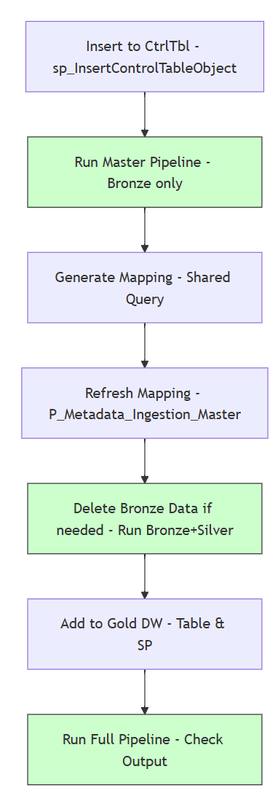
  - Run the Stored Procedure sp_InsertControlTableObject for the new object
  - Execute associated Master Pipeline disabling all other steps except Bronze.
  - Generate Mapping from Shared Query as shown in section below Updating the SourceToTargetMapping
  - Run P_Metadata_Ingestion_Master to refresh the mapping in the system
  - Delete Bronze Data from Step 2 if required, then execute associated Master Pipeline disabling all other steps except Bronze and Silver.
  - Add object to Gold Datawarehouse (including a Gold Table & Gold Stored Procedure as minimum).
  - Run Master Pipeline including all steps and check the output

Tools for Data Ingestion to Bronze

Onboarding a new Object to Bronze
Run the Stored Procedure shown below for the new object. (For details regarding the stored procedure, see 3.1.3.4.1.1 - sp_InsertControlTableObject)
Datawarehouse | Stored Procedure | Parameters | Expected Result
FDWH_Ingestion ControlStore | sp_InsertControl TableObject | - TableName  - SourceObjectSettings  - CopySourceSettings  - SinkObjectSettings  - DataLoadingBehavior  - WatermarkColumnName  - WatermarkQuery | New object will be ingested from the next run onwards

Reset Watermarks for an object in Bronze
Run the Stored Procedure shown below for the desired result. For details regarding the stored procedure see 3.1.3.3.1.2 ResetAllWaterMarks, <Source>_Reset AllWatermarks
Datawarehouse | Stored procedure call | Expected Result
FDWH_Ingestion ControlStore | EXEC ResetAllWatermarks | - Tracked watermark is now reset for all Ingestion Control Tables
FDWH_Ingestion ControlStore | EXEC <Source>_Reset AllWatermarks | - Tracked watermark is now reset for Source Ingestion Control Tables  - Source is one of GOULBDB, SF, BioNet, ePlanning, Planning

Tools for Data Ingestion to Silver

Tools for Remediating Silver Ingestion for a particular Batch ID
This procedure should be followed after remediating an error in Silver. It will re-run the associated Batch of data, ensuring consistency between Bronze and Silver.
  - Upon Failure of an instance of L_MergeBronzeToSilver in Fabric - Monitoring Hub, note the BatchId and source_type as shown: 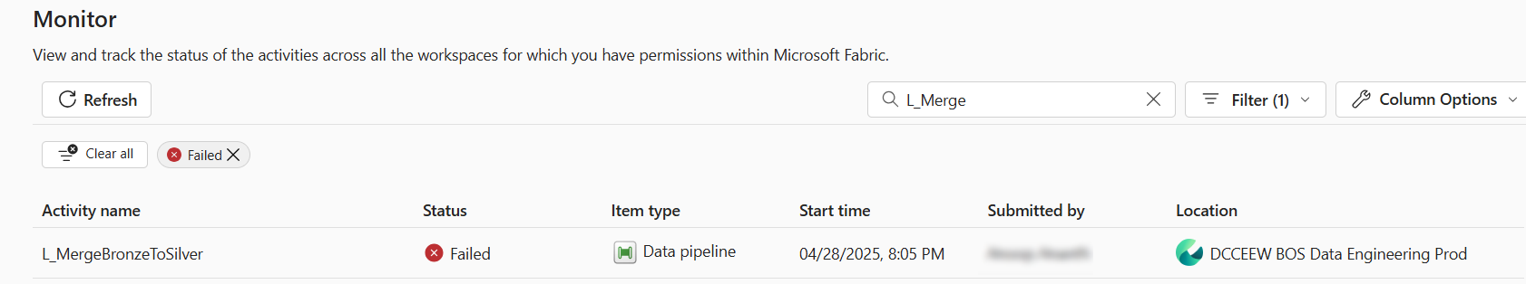
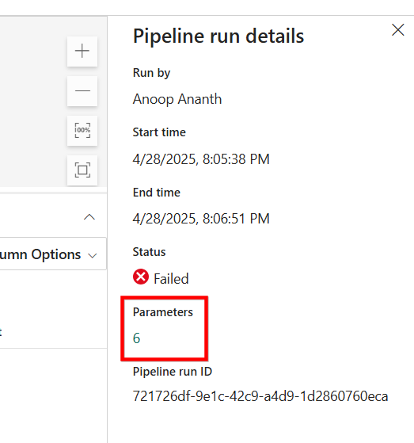

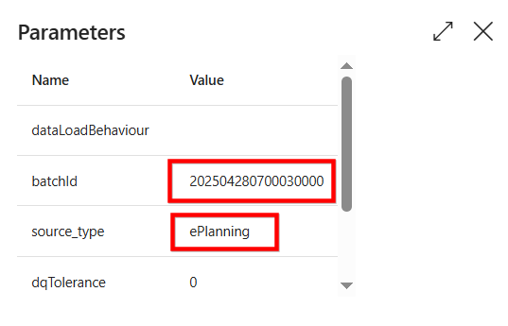
  - Click ‘Update Pipeline’, ‘Run’, and enter the parameters as shown:
- Update Pipeline:
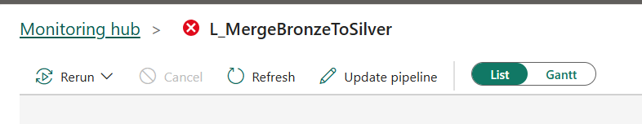

- Run:
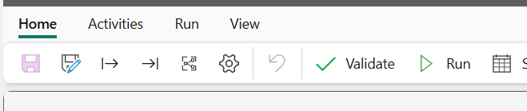
- Parameters:
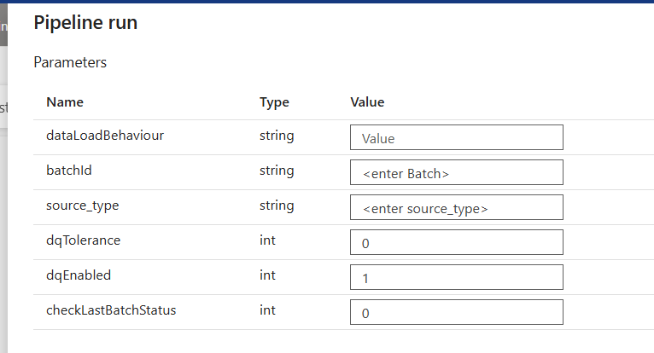
Expected result: Assuming error has been fixed, the above steps will now synchronise the missed data from Bronze to Silver.

Tools for Data Ingestion to Gold
The ingestion from Silver to Gold is handled via Stored Procedures in the Warehouse FDWH_Gold, which use the table [FDWH_Gold].[mgmt].[GoldIngestionBatchStatus] for ingestion control and filters data from Silver using the Last Successful Batch Id. This means that the remediation of a Gold ingestion happens automatically on the next pipeline run, since the logic will disregard a failed run and filter from the last time it was successful.

Tools for Remediating Gold Ingestion for a particular Batch ID
In the case where the ingestion for a particular Batch Id was solved in Silver using the Tool for Remediating Silver Ingestion for a particular Batch ID, the data still needs to be ingested into Gold. The pipeline ‘L_MergeSilverToGold’ is used to run the ingestion:
Pipeline | Parameters | Expected Result
L_MergeSilverToGold | sourceType = <Source>  batchId = <BatchId> | Data from the remediated BatchId will be ingested from silver to Gold.
Important: The parameter sourceType currently only accepts the values ‘Salesforce’, ‘goulbdb’, ‘BioNet’, ‘ePlanning’, ‘SharePoint’, ‘FactTables’ and ’Planning’.
E.g., the ingestion from Silver ePlanning, BatchId 202505032130010000, would run as follows:
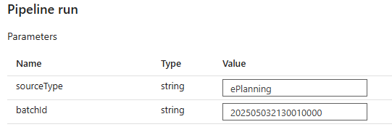

Considerations for the Dim and Fact tables in Presentation_LMBC schema
There is a strong relationship between the GOULDB and Salesforce data sources in constructing the tables within the Gold schema, Presentation_LMBC. Several dimension tables are populated after ingesting the corresponding data from either GOULDB or Salesforce into Silver, using T-SQL notebooks such as N_TSQLSilverToGold_GOULBDB and N_TSQLSilverToGold_Salesforce.
However, most FACT tables rely on data from both schemas being available in Silver. To handle this dependency, the notebook N_TSQLSilverToGold_FactTables orchestrates the ingestion of these Fact tables into Gold. It is triggered only after both GOULDB and Salesforce Silver loads are completed.
This approach aligns with the core principle of the Medallion Architecture, where each layer functions independently. The Gold layer, in particular, is designed to host integrated and aggregated datasets from multiple sources and schemas, ensuring consistency and reusability for reporting and analytics.
In the infrequent case that the user needs to reload the Fact tables because there is a mismatch in the data due to a misalignment of the pipeline runs, the process to reload the Fact tables is as follows:
- Delete all the Fact tables from the Ingestion control table using the script:
DELETE FROM [FDWH_Gold].[mgmt].[GoldIngestionBatchStatus]
WHERE DestinationDatabase = 'FDWH_Gold'
AND DestinationSchema = 'Presentation_LMBC'
AND DestinationTable LIKE 'Fact%'

- Run the Pipeline L_MergeSilverToGold with the following parameters: 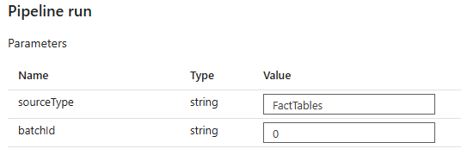
Pipeline | Parameters | Expected Result
L_MergeSilverToGold | sourceType = FactTables  batchId = 0 | FactTables will be reingested into Gold.

Administration and Management

SourceToTargetMapping
Updating the Source to Target Mapping is a BAU activity that updates defined metadata for the system.
The SourceToTargetMapping excel spreadsheet allows flexible ingestion from Bronze to Silver based on metadata definitions of input and output columns.
The SourceToTargetMapping can be found at the following link in Environment SharePoint:
SourceToTargetMapping
Below is an example of the schema of the SourceToTargetMapping:
Column Name | Description
DestinationName | Mandatory – Destination table name
DestinationDescription | Mandatory – Description of the destination, information only
DestinationColumn | Mandatory – Destination column name
DestinationColumnDataType | Mandatory – Destination datatype
DestinationColumnNullable | Mandatory – column can have null values
SourceName | Mandatory – Defines the source name in format data source/dataset
SourceDescription | Mandatory – Description of the source, information only
SourceColumn | Mandatory – for derived values, use the primary key, only used for validation
SourceColumnDataType | Optional – Recommended, not currently used, added for future use cases.
SourceColumnNullable | Optional – Recommended, not currently used, added for future use cases.
SourceMapping | Mandatory – SourceMapping, If no SQL-like derivation/transformation, then same as SourceColumn
isActive | Mandatory – enable/disable a mapping column( 0 – disable, 1 – enabled)

Updating the SourceToTargetMapping
Follow the procedure below to update the Metadata contents:
- Open SourceToTargetMapping and make the required changes
- Run the pipeline P_Metadata_Ingestion_Master in the associated environment (NonProd and/or Prod)
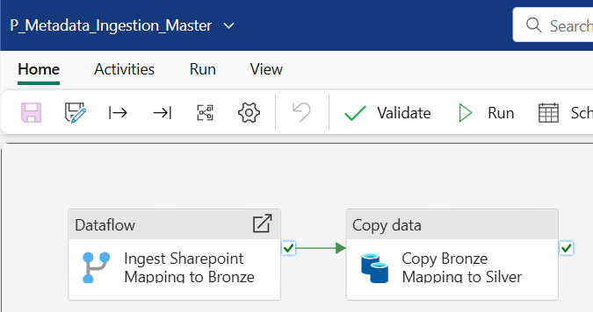
Expected result: The newly ingested metadata is ready to use in pipelines and notebooks from Bronze to Silver.

Shared Query to Generate SourceToTargetMapping from Bronze layer
The below Shared Query in Bronze SQL Endpoint allows a user to form the SourceToTargetMapping (i.e. Bronze to Silver mapping) based on the existing state of Bronze.
- Run Shared Query Generate SourceToTargetMapping from Bronze (Non-Prod, Prod)
- Copy to Excel to observe and correct generated output, if required
- Populate SourceToTargetMapping by copying results to the SharePoint/Excel File linked.

Appendix

Decision Register
The following is a link to the Decision Register within Azure DevOps, which contains a record of key decisions made during the project.
Azure DevOps Decision Register
Decision Register - Boards (azure.com)

Supporting Documents and Artifacts
Document | Details
DPHI Solution Design - Fabric Data Platform-v1.00 | Solution Architecture Design Document

